**IN-SITU TAC**

**CMEMS ELEMENT**



Tests document for CMEMS V4

INSTAC: MED-HCMR-ATHENS-GR

Reference: CMEMS-INS-TD

|  |  |  |
| --- | --- | --- |
| **Validated by:**  Sylvie Pouliquen | **Document release number:**  V1.4 | **Date: 18/01/2018** |
| **Contributors :**  Carval Thierry, Chalkiopoulos Antonis, Perivoliotis Leonidas, De Alfonso Alonso-Muñoyerro Marta, Manzano Munoz Fernando, Tamm Susan, Ringheim Lid Sjur, Linders Johana, Marinova Veselka | | |

Change Record

|  |  |  |  |  |
| --- | --- | --- | --- | --- |
| **Issue** | **Date** | **§** | **Description of Change** | **Author** |
| 1.0 | 31/07/2015 | all | First version of document | Thierry Carval |
| 1.0 | 27/08/2015 | all | Typographic correction | Charles Troupin |
| 1.1 | 27/08/2015 | all | General update of the document format | Thierry Carval |
| 1.2 | 14/12/2015 |  | Feedback from design review | Thierry Carval |
| 1.2 | 14/12/2015 |  | Delayed mode drifting buoys product test | Thierry Carval |
| 1.2 | 16/12/2015 | all | General revision | Marta de Alfonso Alonso-Muñoyerro |
| 1.2 | 17/12/2015 | all | Remove non applicable parts | Thierry Carval |
| 1.3 | 06/01/2017 |  | Update for CMEMS V3  §2.3.1.4 : new chapter for Oceanotron tests  §2.3.6.4 : new chapter for wave specific tests  §2.3.6.4.1 : wave parameters check  §2.3.62.3.6.4.2.4.1 : wave real-time QC check | Thierry Carval |
| 1.3 | 13/01/2017 |  | Tests performed on Mediterranean DU | Antonis Chalkiopoulos |
| 1.3 | 25/01/2017 |  | §2.3.1.4 Oceanotron SOS is not mandatory |  |
| 1.4 | 19/05/2017 |  | Update for V4 | Thierry Carval |
| 1.4 | 15/12/2017 |  | §2.3.2.1 add wave visualization from Oceanotron  §2.3.6.5.3 : checks that wave REP product is available  §2.3.6.6 add BGC specific tests for V4 | Thierry Carval |
| 1.4 | 03/01/2018 |  | Revisions from Marta | Marta de Alfonso Alonso-Muñoyerro |
| 1.4 | 18/10/2018 |  | Tests performed on Mediterannean DU | Antonis Chalkiopoulos  Maria Sotiropoulou |

Table of contents

Change Record 2

Table of contents 3

1 Object of the document 7

2 Test cases specification 8

2.1 Test identification 8

2.2 Core test plan for global or regional components 9

2.2.1 Distribution Unit (DU) interfaces tests 9

2.2.2 DU organisation tests 10

2.2.3 DU performances and robustness tests 11

2.3 Products interfaces testing 11

2.3.1 Delivery / Download Interfaces 13

2.3.1.1 Copernicus-FTP download: EI_D_MFTP_MO 14

2.3.1.2 THREDDS-OPeNDAP download: EI_D_OPENDAP_MO 16

2.3.1.3 Motu subsetter download: EI_D_SUBSETTER_GL 16

2.3.1.4 Oceanotron data server: EI_D_OCEANOTRON_MO 17

2.3.2 Visualization Interfaces 25

2.3.2.1 Test Case Interactive maps: EI_VI_MAP_MO 25

2.3.3 Monitoring Interface 26

2.3.3.1 Get Transaction accounting: II_C_TRANSACTION_ACCOUNTING_MO 27

2.3.3.2 Validate Motu Transaction accounting “logDownloadGW logs: II_C_TRANSACTION_ACCOUNTING_LOGGW_GL 28

2.3.3.3 Validate Download gateway Transaction accounting Apache logs: II_C_TRANSACTION_ACCOUNTING_APACHE_GL 28

2.3.3.4 Validate Transaction accounting APACHE logs for VsFTPd: II_C_TRANSACTION_ACCOUNTING_APACHE_GL 28

2.3.4 Performance testing 29

2.3.5 Tests on all the datasets distributed by the DU <DU> 32

2.3.6 NetCDF files testing 32

2.3.6.1 NetCDF format checker: NC_FO_MO 32

2.3.6.2 CF checker: NC_CF_MO 32

2.3.6.3 NetCDF files title: NC_TI_MO 33

2.3.6.4 PIT compliance: NC_PI_MO 34

2.3.6.5 Wave specific tests for CMEMS V4 34

2.3.6.6 BGC specific tests for CMEMS V4 36

List of Tables

Table 1: Type of interface provided by the Dissemination Unit 12

Table 2: Interfaces test result table 13

Table 3: Interfaces test result table 25

Table 4: Monitoring Status table 26

Table 5: Results of the performance testing 31

Table 6: Differences against PIT V4.0 32

Table 7: NetCDF Files format status 33

Table 8: NetCDF Files status 34

Table 9: Dataset metadata status 34

Table 10: NetCDF Files format status 35

Table 10: NetCDF Files format status 37

List of Figures

Glossary and abbreviations

Additional terms:

|  |  |
| --- | --- |
|  |  |
|  |  |
|  |  |
|  |  |

**Applicable and Reference Documents**

|  |  |  |  |
| --- | --- | --- | --- |
|  | Ref | Title | Date / Version |
| DA 1 | CMEMS-INS-SOW | INSTAC SOW | Version 1.0 January 2015 |
| **DA 2** | CMEMS-INS-PRO | INSTAC Proposal | V1.0 March 2015 |
| **RA 1** |  |  |  |

# Object of the document

This version of the document is dedicated to CMEMS V4 release.

This document presents the test description to validate the interfaces provided by the Distribution Units (DUs).

These tests apply to:

* The external interfaces provided by the Dissemination Unit (DU) through the Dissemination Gateway (data access, view and transaction accounting functionalities).
* The file format and contents.

Chapter Interfaces Testing describes the detailed tests of each type of interface to be run by each Dissemination unit.

Chapter Performance testing presents the performance tests.

In the chapter Tests on all the datasets distributed by the DUs, the interfaces to access all the datasets distributed by the DUs (exhaustive list) are identified and described through an access URL.

The chapter NetCDF files testing describes requirements towards metadata file content and file format.

**These tests have been performed for MED INSTAC DU: MED-HCMR-ATHENS-GR, and the document shows the results.**

# Test cases specification

## Test identification

In order to identify a test by a unique key, we define the following nomenclature:

* XXX-YYY-FFF-NNN,

Where XXX is the test category, YYY a keyword describing the focus in the test, FFF is the functionality and NNN an index number.

There are several test categories:

* Opened Interfaces tests: INT,
* System Organisation: ORG,
* Data validation: DAT: based on operational uses cases

Identified focuses are: FTP for FTP access, WEB for http access, FIL for Data File, IDX for index, FOR for data file format, QUA for quality of the data, DIS for availability of the data, COM for completeness of data files, OCEANOTRON for Oceanotron, TDS for THREDDS, MISG for MISGATEWAY, MOTU for MOTU integration, HOA for production monitoring.

Functionalities are identified by the following keywords:

* REQ for requests,
* MON for monitoring,
* ROB for Robustness
* INV for inventory

## Core test plan for global or regional components

### Distribution Unit (DU) interfaces tests

FTP server

| **Identifier** | **Wording** |
| --- | --- |
| Connectivity | |
| INT-FTP-REQ-000 | Check FTP connectivity success using good login, password and address |
| INT-FTP-REQ-010 | Check FTP connectivity failed using bad login, password and good address |
| INT-FTP-REQ-020 | Check dataset product can be load by basic means (FTP). |
| INT-FTP-REQ-030 | Check the regional extraction from Coriolis Global INS TAC Component to be delivered to the regional INS TAC (check that global region files (GL*.nc) are available in the DU) |
| FTP organization | |
| INT-FTP-REQ-050 | Check well-formed FTP organization for latest data. |
| INT-FTP-REQ-060 | Check well-formed FTP organization for monthly data |
| **Index files** | |
| INT-DAT-DIS-000 | Check the generated index file is the same as the existing index file on FTP |

Oceanotron server

| **Identifier** | **Wording** |
| --- | --- |
| Connectivity | |
| INT-OCEANOTRON-REQ-020 | Check physical profile dataset download with x/y/z/t criteria |
| INT-OCEANOTRON-REQ-030 | Check physical timeseries dataset download with x/y/z/t criteria |
| INT-OCEANOTRON-REQ-040 | Check physical trajectory dataset download with x/y/z/t criteria |
| INT-OCEANOTRON-REQ-050 | Check virtual trajectory dataset (biogeochemistry observations) download with x/y/z/t criteria |
| INT-OCEANOTRON-REQ-055 | Check dataset view with x/y/z/t criteria (OGC/WMS) |

THREDDS Data Server on Global DU

| **Identifier** | **Wording** |
| --- | --- |
| Connectivity | |
| INT-TDS-REQ-020 | Check dataset download with x/y/z/t criteria (OPeNDAP) |
| INT-TDS-REQ-030 | Check dataset view with x/y/z/t criteria (OGC/WMS) |
| Monitoring | |
| INT-TDS-MON-040 | Get XML transaction monitoring file. |

MIs Gateway on Global DU

| **Identifier** | **Wording** |
| --- | --- |
| Connectivity | |
| INT-MISG-REQ-000 | Check MOTU connectivity success using good login, password and address |
| INT-MISG-REQ-010 | Check MOTU connectivity failed using bad login, password and good address |
| INT-MOTU-REQ-020 | Check physical gridded dataset download with x/y/z/t criteria |
| Monitoring | |
| INT-HOA-INV-010 | Get XML production monitoring file |
| INT-MOTU-MON-030 | Get XML transaction monitoring file |

### DU organisation tests

| **Identifier** | **Wording** |
| --- | --- |
| **Index files** | |
| INT—DAT-DIS-000 | Check the generated index file is the same as the existing index file on FTP |
| Data files format | |
| ORG-DAT-QUA-000 | Check that Distribution Unit aggregates input data from Production Units |
| ORG-DAT-QUA-010 | Check the system sends an automatic warning to the Support Operator if data format or content is not valid |
| ORG-DAT-QUA-020 | Check the Production unit sends an automatic warning to the Support Operator if a received data flow is not accessible |
| **Quality of data files (compliance with agreed QC policy)** | |
| ORG-DAT-QUA -030 | Check the RTQC is done only on the new data acquired  (QC flags are set on position, date and vertical level (depth or pressure)) |
| ORG-DAT-QUA -040 | Check the system implements properly T&S RTQC procedure on the acquired data.  (QC flags are set on TEMP and PSAL parameters) |
| ORG-DAT-QUA -050 | Check the system implements properly BIO RTQC procedure on the acquired data.  (QC flags are set on DOXY and CHLA parameters) |
| ORG-DAT-QUA -060 | Check the system implements properly sea level RTQC procedure on the acquired data. (QC flags are set on SLEV parameters) |
| ORG-DAT-QUA -070 | Check the system implements properly current for mooring RTQC procedure on the acquired data. (QC flags are set on current parameters) |
| ORG-DAT-QUA -080 | Check the system implements properly current for drift RTQC procedure on the acquired data. (QC flags are set on drifting buoys currents *_DC_*) |
| **Timeliness of data file updates** | |
| ORG-DAT-DIS-010 | Check the Distribution Unit generates statistic variation of number of files per month |
| ORG-DAT-DIS-020 | Check the Production Unit sends error when there are no data on the latest directory |
| ORG-DAT-DIS-030 | Check the Production Unit sends error when there are no data on the monthly directory |
| ORG-DAT-DIS-040 | Check the Distribution Unit generates statistic variation of number of files per day |
| **Completeness of data files** | |
| ORG-DAT-COM-000 | Productions Unit checks if the number of ~~generated~~ platform is the same that the number of platform on the input data in situ. |
| ORG-DAT-COM-010 | Production Unit checks if the generated file contains all parameters corresponding to the platform |

### DU performances and robustness tests

| **Identifier** | **Wording** |
| --- | --- |
| INT-INS-MON-000 | Check the server availability is in agreement with availability field in FTSS |
| INT-INS-MON-010 | Check the time of download products is lower than the indicated maximum downloaded time configured on NAGIOS. |
| INT-INS-MON-020 | Check the Oceanotron WMS on the last 30 days of observations. The map should be displayed in less than 5 seconds. |

## Products interfaces testing

The interfaces that support the following uses cases (and associated system requirements) have been tested:

* (UC) Visualize Product (interfaces with CIS)
* (UC) Get Product (interfaces with CIS)
* (UC) Monitor user download requests (interfaces with CIS)

| ***Interface types*** | ***Interface unique name*** | ***Comments*** |
| --- | --- | --- |
| Copernicus-FTP | EI_D_MFTP_MO | FTP download, connected with the Copernicus user directory |
| OPENDAP | EI_D_OPENDAP_MO | OPeNDAP interface, can be provided by THREDDS Data Server or by another implementation of an OPeNDAP server. It allows accessing the data through an OPeNDAP client.  Internal interface. |
| SUBSETTER | EI_D_SUBSETTER_MO | Subsetter interface, allow the user to download data through a web client (web browser or command line web client). The data can be extracted, according to criteria. The criteria can be one or more variables, and some geospatial or temporal criteria. |
| DIRECTGETFILE | EI_D_DIRECTGETFILE_MO | Direct Get File, allow the user to download data files of a dataset. A file is identified by its temporal coverage. |
| Interactive maps (Gridded products) | EI_Vi_MAP_MO | THREDDS v4.3 /WMS and Oceanotron |
| Transaction Accounting logs dissemination | II_C_ACCOUNTING_MO | Same interface used for all Transaction Accounting whatever the interface (Copernicus-FTP, SUBSETTER, DIRECTGETFILE…). |

Table 1: Type of interface provided by the Dissemination Unit

### Delivery / Download Interfaces[1]

The DU should perform all the Delivery/ download tests for each dataset.

The results should be set in the following table (Column “Column “FTP”, “OPeNDAP”, “Subsetter” and “Direct get file”) in the sheet “WMSDownloadAuthorizationSummary” of the excel file “DU-Tests results-Summary.xlsx” to be delivered

For in situ TAC DUs, only FTP and WMS are relevant.

Only **core** products type is considered.



Table 2: Interfaces test result table

#### Copernicus-FTP download: EI_D_MFTP_MO

##### Copernicus FTP directories tree: EI_D_MFTP_MO

|  |
| --- |
| **Copernicus FTP directories tree: EI_D_MFTP_MO** |
| Pre-conditions:  The FTP client to run the test can access to internet and is outside your network.  The FTP server is configured **according to Copernicus-FTP installation manual**. |
| Steps:  Open the FTP Client  Open the connection to your server with a Copernicus External Username and password (neither Copernicus Partner nor Major account)  **User: testactivee**  Browse the Copernicus Tree  Check that only “core” directory is visible and browsable **=> OK**  Try to mount one directory level: **cd .. => OK**  Check that only “core” directory still visible and browsable **=> OK**  Check that there is one directory by core product **=> OK**  Check that all expected core product directories names are consistent with their Catalogue name **=> OK**  Close the connection to your server **=> OK** |
| Expected Results:  Test OK. |
| Actual Results :  ../../../../../../../../../Desktop/Screen%20Shot%202018-01-17 |

##### Copernicus FTP download of Core Products: EI_D_MFTP_MO

|  |
| --- |
| **Copernicus FTP download of core products: EI_D_MFTP_MO** |
| Pre-conditions:  The FTP client to run the test can access to internet and is outside your network.  The FTP server is configured **according to Copernicus-FTP installation manual**. |
| Steps:  Open the FTP Client  Open the connection to your server with Copernicus External Username and password  **User: testactivee**  Browse the Copernicus Tree **=> OK**  Check that only “core” directory is visible and browsable **=> OK**  Go to the directory of one product specification : cd **<product specification>**  **cd INSITU_MED_NRT_OBSERVATIONS_013_035**  Check that there is one directory by dataset **=> OK**  Check that all expected dataset directories names are consistent with their catalogue ID **=> OK**  Go to the directory of one dataset: cd **<directory> => cd history/mooring**  Get 2 different files : **get <filename1> ; get <filename2> => OK**  Measure the time needed to download the files  **File 1: GL_TS_MO_61284_2009.nc (233 Mb) => 4.52 sec.**  **File 2: GL_TS_MO_61002.nc (466 Mb) => 8.62 sec.**  Close the connection to your server |
| Expected Results:  All directories are named in conformance with the Catalogue.  The dataset files should have been received on the local machine  The download time shall not exceed **<1 minute>** (depends on the data volume of your file, the requirement (coming from the DA1) is to be able to download 200Mo in less than 1 minute) |
| Actual Results :  ../../../../../../../../../Desktop/Screen%20Shot%202018-01-17 |

#### THREDDS-OPeNDAP download: EI_D_OPENDAP_MO

**THREDDS server is available on Global DU only.**

##### Test on Get ASCII

##### Test through an OPeNDAP client

#### Motu subsetter download: EI_D_SUBSETTER_GL

**The subsetter server is available on Global DU only.**

##### Motu subsetter download of Core Products: EI_D_ SUBSETTER _GL

**Motu subsetter download of Specific Core Products: EI_D_ SUBSETTER _<DU>**

There is no specific In Situ TAC specific core product.

#### Oceanotron data server: EI_D_OCEANOTRON_MO

This chapter is valid for the DU providing Oceanotron data server.

The test of the OGC-SOS service is not mandatory; it is performed on the sites that installed the latest version 2.0.3

##### Test vertical profile observations datasets: INS-HCMR-MED-TS_NRT-OBS_PROFILE_LATEST

###### Test case WMS, visualization back-end

|  |  |  |
| --- | --- | --- |
| **Test Case : WMS** | | |
| Summary: open a graph with the data of the product | | |
| #: | Step actions: | Expected Results: |
| 1 | Open URL: <http://medinsitu.hcmr.gr/oceanotron/WMS> | OK |
| 2 | Under the dataset label (here  INS-HCMR-MED-TS_NRT-OBS_PROFILE_LATEST) click on WMS 1.3.0 getCapabilities | See a well-formed XML getCapabilities result in the web browser in less than 10s. **OK** |
| 3 | Come back on previous page | **OK** |
| 4 | Click on 'University of Reading's WMS web client Godiva3 ' | OK |
| 5 | Click on 'click here to start' | **OK** |
| 6 | Select the dataset by clicking its label (here  INS-HCMR-MED-TS_NRT-OBS_PROFILE_LATEST) in front of the "+" to show location of the observations | a map of white dots shows the location of observation in less than 10s for 1day selection. **OK** |
| 7 | Select a parameter of a dataset by clicking the '+', then the parameter name (e.g. TEMP) | a map of dots colored after the ocean parameter and the colormap. No time limit. **OK** |

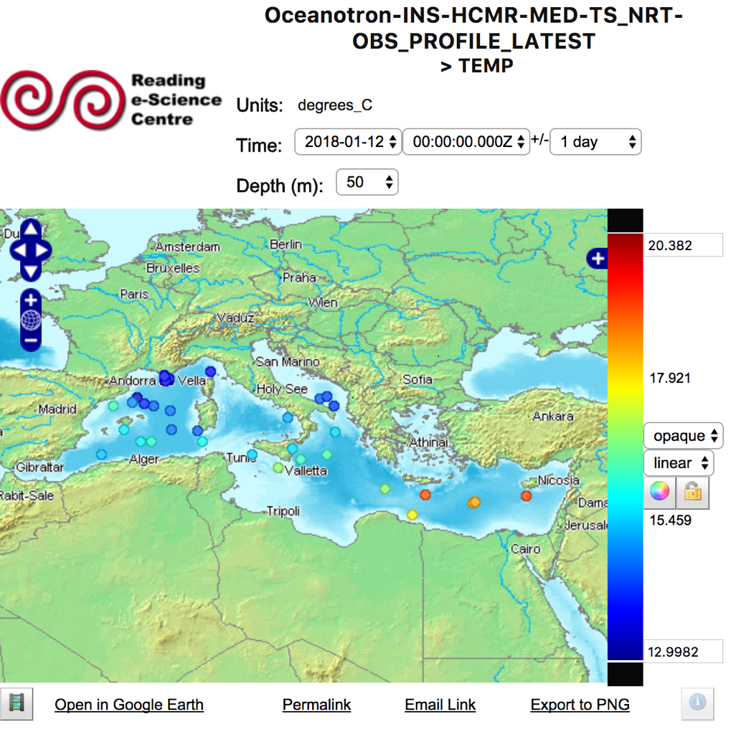

Illustration 1: Oceanotron Mediterranean DU profile dataset on Godiva client

###### Test case OPENDAP, data access back-end

|  |  |  |
| --- | --- | --- |
| **Test Case : OPENDAP** | | |
| Summary: check opendap interface. | | |
| #: | Step actions: | Expected Results: |
| 1 | Go to html opendap interface:  <http://medinsitu.hcmr.gr:8080/oceanotron//OPENDAP/opendap/INS-HCMR-MED-ARGO_NRT-OBS_PROFILE_LATEST.html> | **OK** |
| 2 | Check 'id' and 'lon' attribute and click on 'Get ASCII button. | Get the id and lon attribute for the first 1000 observations in the dataset. **OK** |
| ../../../../../../../../../Desktop/Screen%20Shot%202018-01-17  Illustration 2: Result of OPENDAP Global profile dataset ascii file | | |

###### Test case SOS, data access backend, especially download NetCDF with subsetting

|  |  |  |
| --- | --- | --- |
| **Test Case : SOS** | | |
| Summary: subset data of the product and download result as NetCDF file | | |
| # | Step actions: | Expected Results: |
| 1 | <http://medinsitu.hcmr.gr/oceanotron/client>  Select SOS  INS-HCMR-MED-TS_NRT-OBS_PROFILE_LATEST | **OK** |
| 2 | Use the following command:  curl -X POST -d @getObservationoutof_profile_bandintegration.xml 'http://medinsitu.hcmr.gr/oceanotron/SOS/default?service=SOS&request=getObservation' --header "Content-Type:text/xml"  (cf Annexes for getObservationoutofbandintegration.xml content) | Get a well formed URL as a response. **OK**  'http://medinsitu.hcmr.gr/oceanotron /SOS/download/I INS-HCMR-MED-TS_NRT-OBS_PROFILE_LATEST-361a43-ad76-4bad-d5c4-63f7489cf5d8.nc **OK** |
| 3 | Use the URL in a web browser | Download a NetCDF file containing the request's results. **OK** |
|  | | |

Test time series at fixed location observations datasets (pointSeries): INS-HCMR-MED-TS_NRT-OBS_POINTSERIES_LATEST

##### Test case WMS, visualization back-end

|  |  |  |
| --- | --- | --- |
| **Test Case : WMS** | | |
| Summary: open a graph with the data of the product | | |
| #: | Step actions: | Expected Results: |
| 1 | Open URL: <http://medinsitu.hcmr.gr/oceanotron/WMS> | OK |
| 2 | Under the dataset label (here INS-HCMR-MED-TS_NRT-OBS_POINTSERIES_LATEST)  click on WMS 1.3.0 getCapabilities | See a well-formed XML getCapabilities result in the web browser in less than 10s. **OK** |
| 3 | Come back on previous page | **OK** |
| 4 | Click on 'University of Reading's WMS web client Godiva3 ' | OK |
| 5 | Click on 'click here to start' | **OK** |
| 6 | Select the dataset by clicking its label (here  INS-HCMR-MED-TS_NRT-OBS_POINTSERIES_LATEST) in front of the "+" to show location of the observations | a map of white dots shows the location of observation in less than 10s for 1day selection. **OK** |
| 7 | Select a parameter of a dataset by clicking the '+', then the parameter name (e.g. TEMP) | a map of dots colored after the ocean parameter and the colormap. No time limit. **OK** |
| ../../../../../../../../../Desktop/Screen%20Shot%202018-01-17  Illustration 3: oceanotron Mediterranean time series dataset on godiva client | | |

###### Test case OPENDAP, data access back-end

|  |  |  |
| --- | --- | --- |
| **Test Case : OPENDAP** | | |
| Summary:  check opendap interface. | | |
| #: | Step actions: | Expected Results: |
| 1 | Go to html opendap interface:  <http://medinsitu.hcmr.gr:8080/oceanotron//OPENDAP/opendap/INS-HCMR-MED-TS_NRT-OBS_POINTSERIES_LATEST.html> | **OK** |
| 2 | Check 'id' and 'lon' attribute and click on 'Get ASCII button. | Get the id and lon attribute for the first 1000 observations in the dataset. **OK** |
| ../../../../../../../../../Desktop/Screen%20Shot%202018-01-17  Illustration 4: Result of OPENDAP Mediterranean pointseries dataset ascii file | | |

###### Test case SOS, data access backend, especially download NetCDF with subsetting

|  |  |  |
| --- | --- | --- |
| **Test Case : SOS** | | |
| Summary:  subset data of the product and download result as NetCDF file | | |
| #: | Step actions: | Expected Results: |
| 1 | Open a linux terminal. |  |
| 2 | Use the following command:  curl -X POST -d @getObservationoutof_pointseries_bandintegration.xml 'http://medinsitu.hcmr.gr/oceanotron/SOS/default?service=SOS&request=getObservation' --header "Content-Type:text/xml"  (cf Annexes for getObservationoutofbandintegration.xml content) | Get a well-formed URL as a response. **OK** http://medinsitu.hcmr.gr/oceanotron/SOS/download/ INS-HCMR-MED-TS_NRT-OBS_POINTSERIES_LATEST-86cda6b9f-cb3d-3962-d321-cb35c6ab8934.nc |
| 3 | Use the URL in a web browser | Download a NetCDF file containing the request's results. **OK** |
|  | | |

Test trajectories observations datasets: INS-HCMR-MED-TS_NRT-OBS_TRAJECTORIES_LATEST

##### Test case WMS, visualization back-end

|  |  |  |
| --- | --- | --- |
| **Test Case : WMS** | | |
| Summary: open a graph with the data of the product | | |
| #: | Step actions: | Expected Results: |
| 1 | Open URL: <http://medinsitu.hcmr.gr/oceanotron/WMS> | OK |
| 2 | Under the dataset label (here  INS-HCMR-MED-TS_NRT-OBS_TRAJECTORIES_LATEST) click on WMS 1.3.0 getCapabilities | See a well-formed XML getCapabilities result in the web browser in less than 10s. **OK** |
| 3 | Come back on previous page | **OK** |
| 4 | Click on 'University of Reading's WMS web client Godiva3 ' | OK |
| 5 | Click on 'click here to start' | **OK** |
| 6 | Select the dataset by clicking its label (here  INS-HCMR-MED-TS_NRT-OBS_TRAJECTORIES_LATEST) in front of the "+" to show location of the observations | a map of white dots shows the location of observation in less than 10s for 1day selection. **OK** |
| 7 | Select a parameter of a dataset by clicking the '+', then the parameter name (e.g. TEMP) | a map of dots colored after the ocean parameter and the colormap. No time limit. **OK** |
| ../../../../../../../../../Desktop/Screen%20Shot%202018-01-17  Illustration 5: oceanotron Mediterranean trajectories dataset on godiva client | | |

###### Test case OPENDAP, data access back-end

|  |  |  |
| --- | --- | --- |
| **Test Case : OPENDAP** | | |
| Summary: check opendap interface. | | |
| #: | Step actions: | Expected Results: |
| 1 | Go to html opendap interface:  <http://medinsitu.hcmr.gr:8080/oceanotron//OPENDAP/opendap/INS-HCMR-MED-TS_NRT-OBS_TRAJECTORIES_LATEST.html> | **OK** |
| 2 | Check 'id' and 'lon' attribute and click on 'Get ASCII button. | Get the id and lon attribute for the first 1000 observations in the dataset**. OK** |
| ../../../../../../../../../Desktop/Screen%20Shot%202018-01-17  Illustration 6: Result of OPENDAP Mediterranean trajectories dataset ascii file | | |

###### Test case SOS, data access backend, especially download NetCDF with subsetting

|  |  |  |
| --- | --- | --- |
| **Test Case : SOS** | | |
| Summary: subset data of the product and download result as NetCDF file | | |
| # | Step actions: | Expected Results: |
| 1 | Open a linux terminal. |  |
| 2 | Use the following command:  curl -X POST -d @getObservationoutof_trajectories_bandintegration.xml 'http://medinsitu.hcmr.gr/oceanotron/SOS/default?service=SOS&request=getObservation' --header "Content-Type:text/xml"  (cf Annexes for getObservationoutofbandintegration.xml content) | Get a well-formed URL as a response. **OK**  http://medinsitu.hcmr.gr/oceanotron/SOS/download/ INS-HCMR-MED-TS_NRT-OBS_TRAJECTORIES_LATEST-c698ad67-96a3-3294-a321-a934cf6739a2.nc |
| 3 | Use the URL in a web browser | Download a NetCDF file containing the request's results. **OK** |
|  | | |

### Visualization Interfaces

The DU should perform all the visualization tests for each dataset.

The results should be set in the following table (Column “WMS”) in the sheet “WMSDownloadAuthorizationSummary” of the excel file “DU-Tests results-Summary.xlsx” to be delivered



Table 3: Interfaces test result table

#### Test Case Interactive maps: EI_VI_MAP_MO

|  |
| --- |
| **Test Case Interactive maps: EI_VI_MAP_MO** |
| Steps:  1. Navigate to the dataset <dataset> on your Oceantron/THREDDS server (can be an internal access only) http://<thredds/oceanotron-data-server-URL>/Godiva.html **=>** [**http://medinsitu.hcmr.gr/oceanotron/WMS/Godiva.html**](http://medinsitu.hcmr.gr/oceanotron/WMS/Godiva.html)  2. Select a dataset by clicking on "Click here to start” → see a map of location with white dots. **OK**  3. Select an ocean variable by clicking on a dataset, then on a variable (e.g. TEMP) → see a map of location with dots colored after the ocean variable value. **OK**  4. Click on a location on map and see textual information on observations. **OK**  5. Click on “profile plot” or time series plot” and see a plot of the observation. **OK**  4. Select a wave parameter (VHM0): check that wave platforms appear on the map. **OK** |
| Expected Results:  The View Service test interface should load and display your data.  Visualization display should take less than 10s.  Wave platforms appear on the map. |
| Actual Results:  Test OK, the map of temperatures appears in 3 seconds  ../../../../../../../../../Desktop/Screen%20Shot%202018-01-17  **The temperature observations from WMS service on Godiva interface**  **Wave platforms appear on the map** |

### Monitoring Interface

The results should be set in the following table in the sheet “Monitoring Status” of the excel file “DU-Tests results-Summary.xlsx” to be delivered

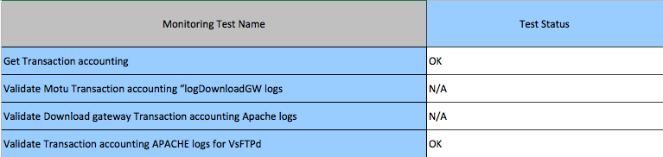

Table 4: Monitoring Status table

#### Get Transaction accounting: II_C_TRANSACTION_ACCOUNTING_MO

|  |
| --- |
| **Availability of the transaction accounting logs through http** |
| Pre-conditions:  Transaction accounting logs produced |
| Steps:  Access the URL  [**http://medinsitu.hcmr.gr/transactions/**](http://medinsitu.hcmr.gr/transactions/)  Check that all expected transaction accounting logs are available:  The ones for the MIS-GW (Motu gateway) download interface with “logDownloadGW.xsd” **=> N/A for MED**  The ones for the MIS-GW (Motu gateway) download and WMS interface in Apache Combined Log Format **=>** **N/A for MED**  The ones for Copernicus-FTP download interface with xferlog and vsftpdlog formats. **=> OK**  Check that the logs contain the transactions you made during the DU testing campaign. |
| Expected Results:  The transaction accounting logs are available and up to date.  Actual Results:  Test OK: The transaction accounting logs are present and up to date.  [**http://medinsitu.hcmr.gr/transactions/**](http://medinsitu.hcmr.gr/transactions/)  ../../../../../../../../../Desktop/Screen%20Shot%202018-01-17  The Mediterranean DU web site for transaction accounting. |

#### Validate Motu Transaction accounting “logDownloadGW logs: II_C_TRANSACTION_ACCOUNTING_LOGGW_GL

**Motu is available on Global DU only.**

#### Validate Download gateway Transaction accounting Apache logs: II_C_TRANSACTION_ACCOUNTING_APACHE_GL

**This accounting is available for Global DU only.**

#### Validate Transaction accounting APACHE logs for VsFTPd: II_C_TRANSACTION_ACCOUNTING_APACHE_GL

|  |
| --- |
| **Validation of the transaction accounting logs** |
| Pre-conditions:  Test of Copernicus-FTP passed.  Transaction accounting logs for VsFTPd produced |
| Steps:  Access the URL **http://<you server>/<your url>** *or the Apache url you have defined (and communicated to CIS) for your FTP logs*  [**http://medinsitu.hcmr.gr/transactions/**](http://medinsitu.hcmr.gr/transactions/)  Download VsFTPd transaction accounting log files: **vsftpdlog** and **xferlog**  Edit these files with an editor  Check that the vsftpdlog and xferlog logfiles are respectively in vsftpdlog format and xferlog format  Check that these logs are monthly generated and effectively contain the user transactions. |
| Expected Results:  The transaction accounting logs are available and valid  Actual Results:  http://medinsitu.hcmr.gr/transactions/accounting-ftp-xferlog.log.2017-12  ../../../../../../../../../Desktop/Screen%20Shot%202018-01-17  [**http://medinsitu.hcmr.gr/transactions/accounting-vsftpd.log.2017-12**](http://medinsitu.hcmr.gr/transactions/accounting-vsftpd.log.2017-12)  ../../../../../../../../../Desktop/Screen%20Shot%202018-01-17  **The transaction accounting of the ftp server in December 2017. The transaction accounting logs are available and valid.** |

### Performance testing

Download 50Mo, 200 and 1Go of 2 different datasets through the different data access services, and measure the time of the download (processing time and downloading time).

The processing time is the time taken by the server to process the request (time between the reception of the request on the server, to the beginning of the answer to the client).

The downloading time is the time between the beginning of the answer by the server and the reception of the entire file stored on the client side.

The goal here is not to compare the performances of the different services[2], nor to compare the performances of the different DUs. The goal is to validate that the DU server is correctly running, with correct performances.

To have a reference to assess correctly the DU performances experienced by Copernicus users, each DU should make the following tests with the dataset with the largest size for one variable and for one day. This value should be set in the “Table 5: results of the performance testing” in the column “DataSet Size”.

**Names of the tests**

Test 1.1.1: download 50Mo of the dataset1, through FTP

Test 1.1.3: download 50Mo of the dataset1, through the subsetter

Test 1.2.1: download 50Mo of the dataset2, through FTP

Test 1.2.3: download 50Mo of the dataset2, through the subsetter

Test 2.1.1: download 200Mo of the dataset1, through FTP

Test 2.1.3: download 200Mo of the dataset1, through the subsetter

Test 2.2.1: download 200Mo of the dataset2, through FTP

Test 2.2.3: download 200Mo of the dataset2, through the subsetter

Test 3.1.1: download 1000Mo of the dataset1, through FTP

Test 3.1.3: download 1000Mo of the dataset1, through the subsetter

Test 3.2.1: download 1000Mo of the dataset2, through FTP

Test 3.2.3: download 1000Mo of the dataset2, through the subsetter

The tests are run as follows:

* One test is implemented by many requests; each request asks for one-time step of the dataset (each request asks for a different time step)
* The number of requests is adapted to the datasets requested, in order to reach the data volume of the test: perform as many requests as needed to reach the data volume of the test. If it’s impossible to reach the data volume of the test, because for example the smallest data file distributed by the DU is bigger than 50Mb, then detail the data volume downloaded.
* Each test is run at least 10 times, the final results are the averaged times (processing and downloading)

Example of shell script, requesting many time steps of a dataset on DGF or subsetter:

*DATES=(2012-10-11 2012-10-12) #etc... the time steps shall be different for each request!*

*# Loop on the dates*

*for (( i = 0 ; i < ${#DATES[@]} ; i++ ))*

*do*

*#Download request*

*python motu-client-python/motu-client.py -u opemis -p GUfoxipi -m* [*http://atoll.mercator-ocean.fr/mfcglo-mercator-gateway-servlet/Motu*](http://atoll.mercator-ocean.fr/mfcglo-mercator-gateway-servlet/Motu) *-s* [*http://purl.org/Copernicus/ontology/service/database#GLOBAL_ANALYSIS_FORECAST_PHYS_001_001_d-TDS*](http://purl.org/myocean/ontology/service/database#GLOBAL_ANALYSIS_FORECAST_PHYS_001_001_d-TDS) *-d global-analysis-forecast-phys-001-001-d-glo -o ./ -z Surface -Z 5500 -v v -v u -t ${DATES[$i]} -T ${DATES[$i]} --out-name test_mfc_glo_${DATES[$i]}.nc*

*done*

In the output of the command, the processing time and downloading time are explicitly described.

For example:

10:44:19 [ INFO] Processing time: 0:00:04.886089

10:44:19 [ INFO] Downloading time: 0:00:04.990661

10:44:19 [ INFO] Total time : 0:00:09.876750

10:44:19 [ INFO] Download rate : 4.5 MB/s

10:44:23 [ INFO] Done

The results should be set in the following table in the sheet “Performances” of the excel file “DU-Tests results-Summary.xlsx” to be delivered. Only FTP column is relevant for in situ.

**Tests results**

**We have performed the tests 10 times and then computed the averaged values. The tests have been run only by FTP (see note below). The tests were performed on the following products:**

* **Product 1: INSITU_MED_NRT_OBSERVATIONS_013_035**
* **Product 2: INSITU_MED_TS_REP_OBSERVATIONS_013_041**

**Product 1**

**Test 1.1.1: download 50 Mb of product 1, through FTP**

[**ftp://medinsitu.hcmr.gr/Core/INSITU_MED_NRT_OBSERVATIONS_013_035/history/mooring/GL_TS_MO_61191.nc**](ftp://medinsitu.hcmr.gr/Core/INSITU_MED_NRT_OBSERVATIONS_013_035/history/mooring/GL_TS_MO_61191.nc)

**54.9 Mb => ~1.6 s (Rate: ~35 Mb/s)**

**Test 2.1.1: download 200 Mb of product 1, through FTP**

[**ftp://medinsitu.hcmr.gr/Core/INSITU_MED_NRT_OBSERVATIONS_013_035/history/profiler-glider/GL_PR_GL_18956.nc**](ftp://medinsitu.hcmr.gr/Core/INSITU_MED_NRT_OBSERVATIONS_013_035/history/profiler-glider/GL_PR_GL_18956.nc)

**204 Mb => 4.75 s (Rate: ~48 Mb/s)**

**Test 3.1.1: download 1000 Mb of product 1, through FTP**

[**ftp://medinsitu.hcmr.gr/Core/INSITU_MED_NRT_OBSERVATIONS_013_035/history/profiler-glider/GL_PR_GL_68452.nc**](ftp://medinsitu.hcmr.gr/Core/INSITU_MED_NRT_OBSERVATIONS_013_035/history/profiler-glider/GL_PR_GL_68452.nc)

**1600 Mb => 39.7 s (Rate: ~47 Mb/s)**

**Product 2**

**Test 1.2.1: download 50 Mb of product 2, through FTP**

[**ftp://medinsitu.hcmr.gr/Core/INSITU_MED_TS_REP_OBSERVATIONS_013_041/history/profiler-glider/GL_PR_PF_6902700.nc**](ftp://medinsitu.hcmr.gr/Core/INSITU_MED_TS_REP_OBSERVATIONS_013_041/history/profiler-glider/GL_PR_PF_6902700.nc)

**51 Mb => 1.5 s (Rate: ~34 Mb/s)**

**Test 2.2.1: download 200 Mb of product 2, through FTP**

[**ftp://medinsitu.hcmr.gr/Core/INSITU_MED_TS_REP_OBSERVATIONS_013_041/history/profiler-glider/GL_PR_PF_6902828.nc**](ftp://medinsitu.hcmr.gr/Core/INSITU_MED_TS_REP_OBSERVATIONS_013_041/history/profiler-glider/GL_PR_PF_6902828.nc)

**200 Mb => 4 s (Rate: ~49 Mb/s)**

**Test 3.2.1: download 1000 Mb of product 2, through FTP**

**There is no such big file on product 2. The above tests give detailed download times.**

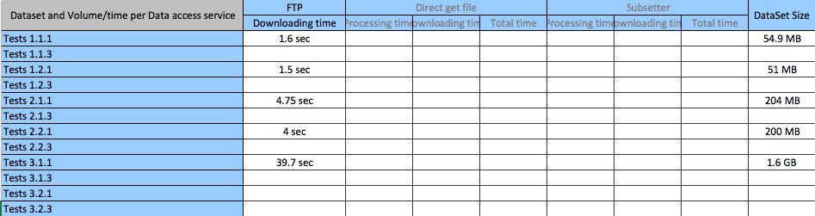

Table 5: Results of the performance testing

### Tests on all the datasets distributed by the DU <DU>

All the datasets distributed by the Dissemination Unit shall be tested, through all the applicable interfaces: download (OPeNDAP, subsetter, direct get file, Copernicus FTP), view (WMS).

The URL should be set in the following table only if this URL is different than the URL existing in the PIT last version. Please note here the PIT release taken into account.

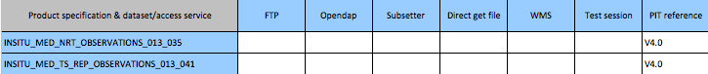

Table 6: Differences against PIT V4.0

### NetCDF files testing

#### NetCDF format checker: NC_FO_MO

Each file of the Distribution Unit should be checked against the Copernicus NetCDF format checker (available on <http://doi.org/10.17882/45538>, updated on January 15th 2018).

The checker tests the format, the mandatory global attributes and the parameter names and attributes (cf standard name, long name, unit).

Among other checks, it will test the new BGC (bio) parameters of the V4 product.

Example: check the GL_LATEST_TS_DB_4601571_20170519.nc file format. The <file_compliant> should be “YES”.

NetcdfChecker $SRC/GL_LATEST_TS_DB_4601571_20170519.nc

<?xml version="1.0"?>

<coriolis_function_report>

<function>CO-03-08-03</function>

<comment>Control file data format</comment>

<date>19/05/2017 12:36:06</date>

<netcdf_file>/home/oo18/coriolis/co01/co0134/co013407/co01340701/latest/20170519/GL_LATEST_TS_DB_4601571_20170519.nc</netcdf_file>

<rules_file>B_CF-1.6_OceanSITES-Manual-1.2_Copernicus-InSituTAC-SRD-1.3_Copernicus-InSituTAC_20170321.xml</rules_file>

<data_type>OceanSITES vertical profile|OceanSITES time-series data|OceanSITES trajectory data|OceanSITES trajectoryProfile data</data_type>

<format_version>1.2</format_version>

<conventions>CF-1.6 OceanSITES-Manual-1.2 Copernicus-InSituTAC-SRD-1.3 Copernicus-InSituTAC-ParametersList-3.0.0</conventions>

<file_compliant>yes</file_compliant>

<status>ok</status>

</coriolis_function_report>

#### CF checker: NC_CF_MO

A CF checker should be applied on all the NetCDF files. This utility checks the file compliance with the CF1.0 (at least) conformance requirements and recommendations.

The results should be set in the following table (Column “CF Checker”) in the sheet “NetCDF files Status” of the excel file “DU-Tests results-Summary.xlsx” to be delivered.

**The CF Checker errors have been included in the report in a new sheet with the name “CF checker errors”.**

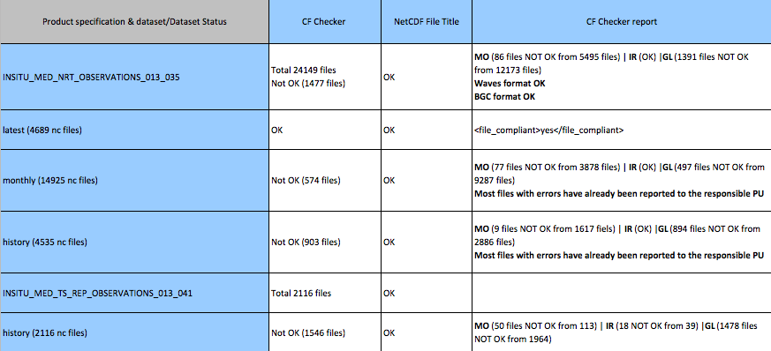

Table 7: NetCDF Files format status

#### NetCDF files title: NC_TI_MO

The DU should make sure that” Title” NetCDF parameter is correctly updated.

The field “Title” should be initialized from the PIT document (column AD “Proposed Title within NetCDF (to appear in view window menu)” in the last PIT document).

|  |
| --- |
| **NetCDF “title” field** |
| This test should be launched for all the NetCDF files.  Steps:  1. Go the NetCDF file directory. cd <directory>  2. Launch the command line: ncdump -h <NetCDF_File_Name>.nc  3. Check that the field “Title” is consistent with the PIT (column AD “Proposed Title within NetCDF (to appear in view window menu)”) |
| Expected Results:  The “title” field should be consistent with the PIT for product created from V3.1.  For all products, this status about Title must be done. Correction of Title, if needed, will be scheduled with project and according to user impacts. |
| Actual Results:  OK, the title field is consistent with the PIT. |

The results should be set in the following table (Column “NetCDF File Title”) in the sheet “NetCDF files Status” of the excel file “DU-Tests results-Summary.xlsx” to be delivered



Table 8: NetCDF Files status

#### PIT compliance: NC_PI_MO

The DU should check the compliance with the PIT for all the dataset. This compliance should be checked for all the column of the PIT document.

The results should be set in the following table (Column “PIT Compliance”) in the sheet “DataSet Status” of the excel file “DU-Tests results-Summary.xlsx” to be delivered



Table 9: Dataset metadata status

#### Wave specific tests for CMEMS V4

##### Wave parameters check: NC_WA_PA_MO

The In Situ TAC format checker is applied on the DU NetCDF files.

Each wave parameter variable name and attributes should be compliant with the “Copernicus In Situ parameters list” available on the SRD landing page:

*Copernicus Marine In Situ Tac Data Management Team (2016). Copernicus in situ TAC - CMEMS System Requirements Document.* [*http://doi.org/10.13155/40846*](http://doi.org/10.13155/40846)

The results should be set in the following table (Column “Wave format check”) in the sheet “NetCDF files Status” of the excel file “DU-Tests results-Summary.xlsx” to be delivered.



Table 10: NetCDF Files format status

##### Wave data real time QC: NC_WA_QC_MO

This test checks that wave parameters have their QC set according to the wave QC manual.

The real-time quality control is applied on wave parameters.

The wave RTQC is documented on: *Copernicus Marine In Situ Team (2016). Copernicus In Situ TAC, Real Time Quality Control for WAVES.* [*http://doi.org/10.13155/46607*](http://doi.org/10.13155/46607)

A KPI is a Key Performance Indicator (<http://www.marineinsitu.eu/monitoring/>). The KPI-3a monitors the percentage of good wave data in the last month. If quality control is not applied, KPI-3a will be a flat line at 0.

|  |
| --- |
| **NC_WA_QC_MO** |
| Steps:  1. Visualize the KPI-3a **=> OK** |
| Expected Results:  The graphic should not be a flat line set to 0.  You can expect more than 70% of wave data flagged good (QC flag = 1) |
| Actual Results:  **Test OK. Data is quality controlled and good data percentage is about 93%**  ../../../../../../../../../Desktop/Screen%20Shot%202018-01-18 |

##### Wave data REP product availability: NC_WA_REP_MO

This test checks that the wave REP product is available for download on the in situ TAC Mediterranean DU.

**Test OK: Wave REP product is available for download in**

[**ftp://medinsitu.hcmr.gr/Core/INSITU_MED_TS_REP_OBSERVATIONS_013_041/history/**](ftp://medinsitu.hcmr.gr/Core/INSITU_MED_TS_REP_OBSERVATIONS_013_041/history/)

#### BGC specific tests for CMEMS V4

##### BGC parameters check: NC_BG_PA_MO

The In Situ TAC format checker is applied on the DU NetCDF files.

Each BGC parameter variable name and attributes should be compliant with the “Copernicus In Situ parameters list” available on the SRD landing page:

*Copernicus Marine In Situ Tac Data Management Team (2016). Copernicus in situ TAC - CMEMS System Requirements Document.* [*http://doi.org/10.13155/40846*](http://doi.org/10.13155/40846)

The results should be set in the following table (Column “BGC format check”) in the sheet “NetCDF files Status” of the excel file “DU-Tests results-Summary.xlsx” to be delivered.



Table 10: NetCDF Files format status

##### BGC data real time QC: NC_BG_QC_MO

This test checks that BGC parameters have their QC set according to the BGC QC manual.

The real-time quality control is applied on BGC parameters.

The BGC RTQC is documented on: *Copernicus Marine In Situ Team (2017). Copernicus In Situ TAC, Real Time Quality Control for BGC. http://doi.org/10.13155/xxx*

A KPI is a Key Performance Indicator (<http://www.marineinsitu.eu/monitoring/>). The KPI-3a monitors the percentage of good oxygen and chlorophyll data. If quality control is not applied, KPI-3a will be a flat line at 0.

|  |
| --- |
| **NC_BG_QC_MO** |
| Steps:  1. Visualize the KPI-3a **=> OK** |
| Expected Results:  The graphic should not be a flat line set to 0. |
| Actual Results:  **Test OK. Data is quality controlled.**  ../../../../../../../../../Desktop/Screen%20Shot%202018-01-18 |

##### BGC data REP product availability: NC_BG_REP_MO

This test checks that the BGC REP product is available for download on the in situ TAC Mediterranean DU.

**Test OK: BGC REP product is available for download in**

[**ftp://medinsitu.hcmr.gr/Core/INSITU_MED_TS_REP_OBSERVATIONS_013_041/history/**](ftp://medinsitu.hcmr.gr/Core/INSITU_MED_TS_REP_OBSERVATIONS_013_041/history/)

**The end**

1. For the execution of these tests a representative dataset file shall be used.
2. Of course the processing time of the FTP service is always 0. But you can note that the only way to decrease the downloading time (and the data volume) is to request a subset of the dataset, instead of the entire coverage (i.e. using the subsetter).