IN SITU TAC
CMEMS ELEMENT

2015 Annual Activity Report
Reference: CMEMS-INS-AAR-2015

Validated by: S Pouliquen | Document release number: V1.1 | Date: 05-01-2016
Contributors : All INSTAC partners

Change Record

Issue | Date | § | Description of Change | Author
1.0 |  | all | First version of the AAR  Prise en compte des inputs de Giulio gnotarstefano | S Pouliquen with all INSTAC Members
1.1 |  | All | Second version | LPV. Typo corrections

Table of contents

Table of contents 3
I Overview of the 2015 INSTAC activities 7
II Management report 8
III Operation and service activities 10
III.1 Global Ocean : 11
III.1.1 Global T&S REP product CORA 4.2 : Updates and validation 12
III.2 Arctic Ocean 16
III.3 Baltic Sea 18
III.4 NWS 20
III.5 IBI 22
III.6 Mediterranean Sea 24
III.7 Black Sea 26
IV TASK 3 SYSTEM EVOLUTION 28
IV.1 Toward the creation of a CMEMS temperature and salinity database with the best features of EN.4 and CORA (Task 3.1.1) 28
IV.2 Current REP product (Task 3.1.2) 29
IV.3 T&S Regional REP product (Task 3.1.3 ) 30
IV.4 Developing historical REP Bio product (Task 3.2 ) 31
IV.4.1 EMODnet 31
IV.4.1.1 Phosphate 31
IV.4.1.2 Nitrate 32
IV.4.1.3 Ammonium concentration parameters in the water column 33
IV.4.1.4 Chlorophyll-a 34
IV.4.2 EEA 34
IV.4.2.1 Chlorophyll 35
IV.4.2.2 Dissolved inorganic nitrogen 35
IV.4.3 ICES 35
IV.4.4 HELCOM 36
IV.4.5 The Baltic Environmental Database. 37
IV.4.6 Ferrybox online data 37
IV.4.7 Bio-ARGO 37
IV.4.8 Status at CMEMS INSTAC and future work 38
IV.5 Developing NRT and Historical Wave product (Task 3.3 ) 39
IV.6 Improving the Interface with CIS(Task 3.4.1) 45
IV.7 Improving Interfaces with MCF (Black List) (Task 3.4.2) 46
IV.8 Provider uptake and Link with EMODNet and EEA: EuroGOOS (Task 3.4.3 ) 48
V TASK 4 CROSS CUTTING ACTIVITIEs 51
V.1 Product Quality (Task 4.1) 51
V.2 Multi Year data Timeseries and Ocean State Report (Task 4.2) 51
V.3 Service Evolution (Task 4.3) 52
V.4 Communication (Task 4.4) 52
V.5 Training (Task 4.5) 53
VI Status of Deliverables 55

List of Tables
Table 1: Delayed time mode validation logs. 13
Table 2 : Number of platforms measuring wave parameters in each regional DU. (Active*: at least one transmission in the last 30 days). The tests were performed on 28.07.2015. 39
Table 3: List of wave parameters used in NetCDF (shaded blue background corresponds to the most common ones). 41
Table 4 : Proposal for wave parameters in NetCDF. Green font corresponds to new entries, red font indicates items to be eliminated. 43
Table 5: Spectral information used in Real Time. 44

List of Figures

Figure 1 : Where are INSTAC Users coming from based on INSTAC logs at Global scale with a focus on Europe. The size of the dots depends on the number of download performed. The colour depends on where the user connected to access INSTAC products : Blue for the Coriolis Global portal, Red for the SMHI Baltic one, Green for the IOBAS Black Sea one, Purple for the IMR Arctic server, Yellow for the PdE IBI one, Grey for the HCMR Med one and Orange for the BSH NWS server. 9
Figure 2 Number of updated profiles per 1°squared cell. SHOM dataset (top) and 2014 dataset (bottom). 13
Figure 3 yearly number of validated profiles (red), number of alert profiles (green), number of validated flagged profiles (blue). 15
Figure 4 : Estimation of profiles provided by the CORA 4.2 dataset (dashed lines), the EN.4 (doted lines) and total amount of unique profiles (bold lines). 28
Figure 5: Number of ocean surface current measurements for the 01-01-1990 to 31-12-2014 period, in 5°x5° boxes 29
Figure 6: Monthly number of drifters (left) and of ocean surface current measurements (right) for the 01-01-1990 to 31-12-2014 period 30
Figure 7 : Planned schedule for Wave products development. 39
Figure 8 : Platforms measuring wave parameters (Active & Historical) 40
Figure 9 : Comparison of climatological test efficiency compared to Min/max method 46
Figure 10 : left panel, shows the validity interval centre shift estimated as the difference between the centre of the min/max interval and the mean value from the same historical dataset , right panel shows the validity interval width ratio or effective N parameter estimated as the ratio of the min/max interval width to twice the standard deviation. 47
Figure 11 : Comparison of the two method efficiency 48

Applicable and Reference Documents

 | Ref | Title | Date / Version
DA 1 | CMEMS-INS-SOW | INSTAC SOW | V1.0 January 2015
DA 2 | CMEMS-INS-PRO | INSTAC Proposal | V1.0 March 2015

Overview of the 2015 INSTAC activities
2015 has been a ramp up period to move from a series of projects to an operational service. The first goal has been to guaranty the continuity of service with MyOcean under very tight delays that have caused some difficulties in particular when partners had positions to open and couldn’t do it without signed contract with Mercator. Priority has been given to the NRT operations and service. All regions committed with the 12h delivery target between 99% and 100% of the time (maximum outage 2 times 1 day interruption for one DU over the 245 day period)
The second target has been to stabilize the number of providers and platforms connected in real-time. We also performed an analysis of the completeness of our data streams in term of parameters integrated, simplification of the link with providers in overlapping regions, standardization between the different INSAC DU for the new parameters (wave, bio) (activity performed between TASK1 and TASK3). Another activity, done jointly with EMODnet-physics and EuroGOOS , is underway and will continue in 2016 is the improvement of the REP products not only for T&S but also for Current, Wave and Bio.
An important activity has been the preparation for the different reviews in a way that was different from the FP7 MyOcean projects and that has required more man power than originally planned. It is mainly due to the fact that the schedule was too tight both for Mercator Project Office and for the INSTAC partners. This was the case for the preparation for the reviews but also for the cross-cutting activities that only started at the end of 2015 and where we are still in a ramp-up period. The INSTAC partners contributed to the different meetings that were held during the last quarter of 2015 (Product Quality, Multi-year product, Ocean State Report, Training workshops) but we would like to point out that presently the requirements from Mercator still need to be clarified with the INSTAC partners so that we can contribute efficiently and plan properly the activity.
Preparing the new CMEMS versions is an important activity for the INSTAC partners, carried on under TASK 3 on service evolution. Activities are progressing as planned towards the elaboration of new historical products and the enhancement of assessment procedures both at global and regional scales.
Finally we have started reviewing our monitoring tools in order to strengthen both the reliability and the quality of the service delivered. At the end of 2015 we performed an analysis of where the INSTAC users were coming from. This analysis is based on the INSTAC DU logs and is summarized in the Figure 1. It shows that INSTAC users connect to all the INSTAC DUs and that the global service is used outside Europe even if we didn’t advertise it so far. We plan to continue this monitoring as clearly in some regions the service should be more used than it is presently. We plan to perform this activity in collaboration with Mercator-Océan.
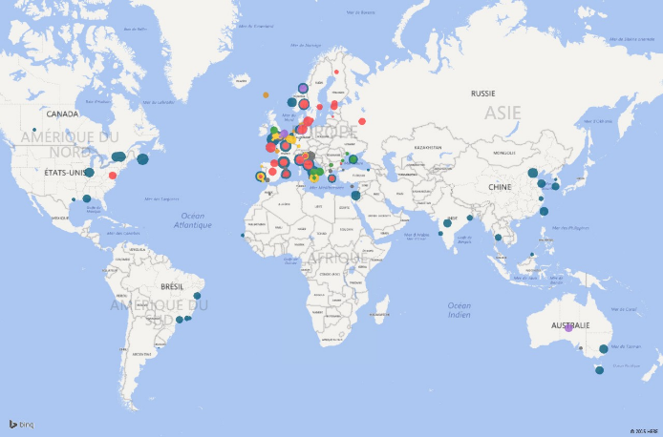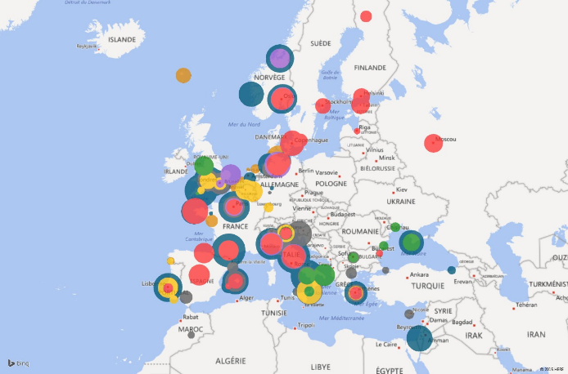
Figure 1 : Where are INSTAC Users coming from based on INSTAC logs at Global scale with a focus on Europe.
The size of the dots depends on the number of download performed.
The colour depends on where the user connected to access INSTAC products : Blue for the Coriolis Global portal, Red for the SMHI Baltic one, Green for the IOBAS Black Sea one, Purple for the IMR Arctic server, Yellow for the PdE IBI one, Grey for the HCMR Med one and Orange for the BSH NWS server.

Management report
In 2015 the management on the INSTAC has been organized along 3 main axis
- Steering the INSTAC activities through periodic Steering Team meetings that are organized as WEBEX meetings. 4 WEBEX Steering Team conferences were organized in 2015 in addition to a plenary meeting that was organized in Brussels. The steering team is in charge of tracking the actions initiated either during reviews with Mercator, during plenary meetings or during steering team meetings. Documentation sharing is done through an owncloud system set up and hosted by Ifremer. The steering team is also in charge of the reporting activities that are performed on monthly and annual basis as well as the coordination of the deliverables for reviews.
- Organizing and monitoring the Service to users: the service organisation has been described in the SIOPM, the downscaling from Central Service Desk (Central SD) to regional DUs . An alarm system will be set up using the monitoring tools (Nagios/Icinga) operated by Ifremer to detect incidents before the users and Mercator-Ocean.
- Enhance the technical coordination to keep coherency between the different implementations of the SRD in the different DU. The Steering Team decides the changes and describes them in the steering team minutes. The technical coordination coordinates its implementation within the INSTAC, its documentation ( SRD) and how to test it (TD) and validates the tests after implementation.
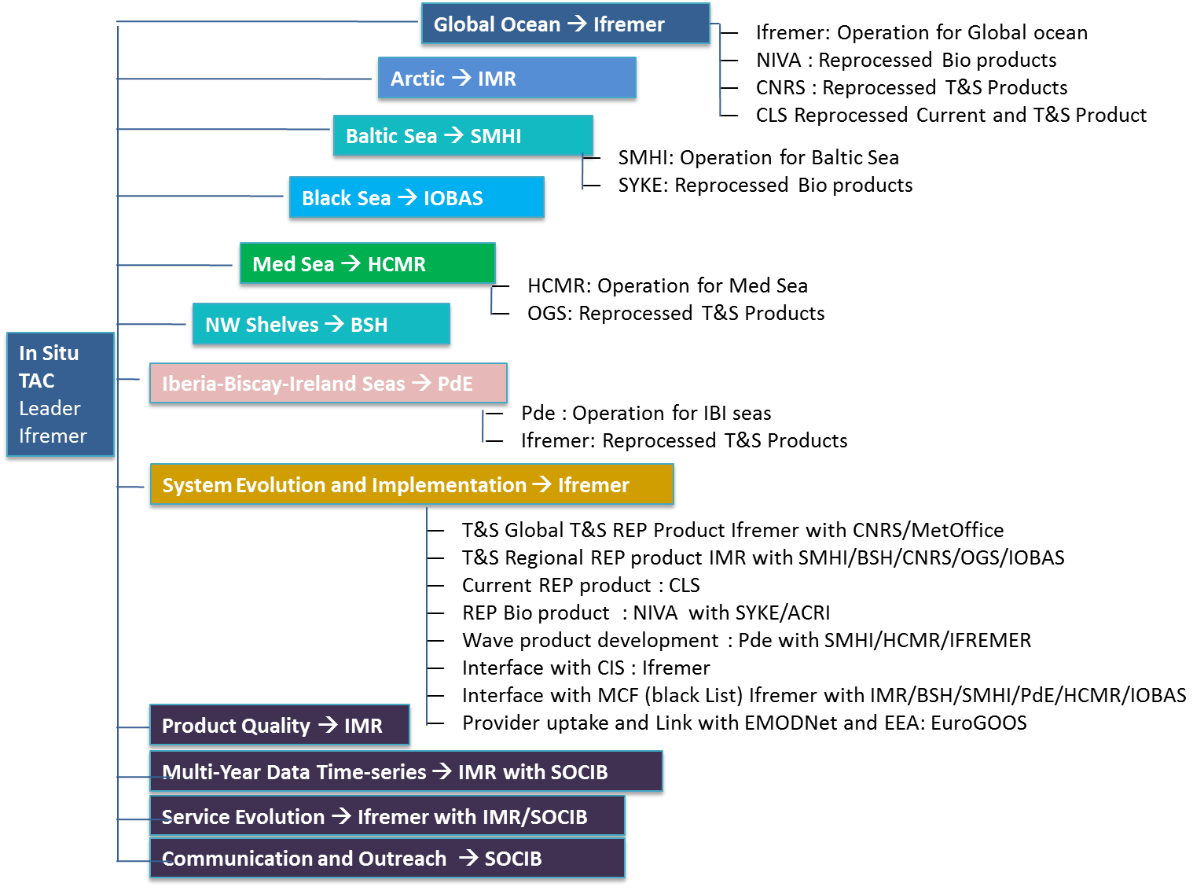
Figure 2: INSTAC partner responsabilities

Operation and service activities
In this first part of this report, we will report on the operations carried on in the different INSTAC components in terms of upstream interfaces
- Number of providers connected to the INSTAC servers per month
- Number of platforms integrated in each region per month
- For each of the parameters mentioned in the [DA2] the number of platforms providing that parameter each month
As there are overlaps between regions, some providers and platforms may be double-counted.
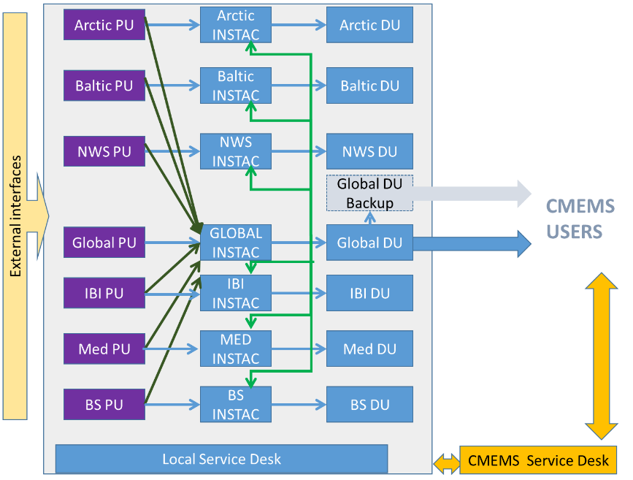
Figure 3: INSTAC Interfaces
We also report in terms of service to users from each INSTAC server:
- Number of files distributed per month
- Number of single users per month
- Volume downloaded on FTP per month
We also provide a synthetic view of the reliability of the Product Delivery the same way as in monthly reports but for a longer period.
Finally we summarized the status of the incidents raised in 2015 for each region.

Global Ocean :
In the Global INSTAC component, Ifremer/Coriolis is in charge of the coordinating of the activities and also has the responsibility for the data distribution, quality control and reporting on operational activities as it is foreseen in the contract and providing support to the global ocean INSTAC users (service desk).
CNRS with CLS is in charge of the T&S REP product assessment (see III.1.1). CNRS Coriolis R&D team also supports Ifremer in the improvement of the assessment methods taking benefit of the delayed mode activity to detect weaknesses in the near real time processing and defining actions to improve the overall system.
Ifremer is constantly working on the timely products provision together with the tracking of every process or transaction taking place in the Global INSITU TAC.
The following table summarizes the Global INSTAC activity in term of NRT service to users and monitoring of the operations.

Data integration
Month | May | June | July | August | September | October | November | December
Number of institutes connected per month since 1st May 2015 | 131 | 125 | 124 | 121 | 130 | 127 | 119
Total Number of platforms integrated per month | 7843 | 7747 | 7714 | 7756 | 7762 | 7775 | 6681
Number of Platforms per parameter per month
Temperature | 7082 | 6974 | 6927 | 6957 | 6971 | 6984 | 5914
Salinity | 4258 | 4191 | 4168 | 4134 | 4119 | 4191 | 3274
Current | 1363 | 1324 | 1308 | 1325 | 1342 | 1337 | 1223
BIO | 262 | 243 | 240 | 241 | 243 | 243 | 183
Wave | 203 | 202 | 199 | 195 | 197 | 215 | 207
Other | 2807 | 2756 | 2747 | 2793 | 2838 | 2795 | 2601
Service to users
Number of files distributed per month | 2002770 | 2302857 | 2201713 | 216025 | 2583528 | 1833725 | 1506869
Number of single users per month | 18 | 27 | 28 | 23 | 30 | 28 | 32
Volume downloaded on FTP per month | 113.32 Gb | 114.822 Gb | 131.509 Gb | 234.368 Gb | 239.781 Gb | 155.717 Gb | 167.923 Gb

Reliability of the Product Delivery
Product Specification Customer Name  For each product of the CMS Element | Target delivery time  (UTC) | Products delivered late by Target date:time  during the Year 2015  Number of occurrences within the period when the target was not reached | Theorical product updates numbers for year 2015 | Please provide an explanation why target delivery time was not achieved
INSITU_GLO_NRT_OBSERVATIONS_013_030 | 12h daily | 0 | 245
INSITU_GLO_TS_REP_OBSERVATIONS_013_001_b | Once a Year | N/A | N/A
INSITU_GLO_TS_OA_NRT_OBSERVATIONS_013_002_a | Monthly | N/A | 7
INSITU_GLO_TS_OA_REP_OBSERVATIONS_013_002_b | Once a year | N/A | N/A

Incidents/Problems for 2015
CMEMS  N° | Raised  Date | Description | RESP  DU | Status | resolved | comment
2716 | 20/05/2015 | Download Issue with Ifremer Motu | GLO | Closed | 21/05/2015
2733 | 20/05/2015 | Salinity 2015-04 in 013_002_a | GLO | Closed | 22/05/2015
2739 | 21/05/2015 | Data from Pacific Mooring are missing | GLO | Closed | 30/07/2015 | All data were reloaded between the 21 and the 30th of July
2872 | 29/06/2015 | Wrong access rights on a file of the product 013_001_b | GLO | Closed | 29/06/2015
3152 | 27/09/2015 | Network failure at Ifremer | GLO | Closed | 28/09/2015
3300 | 10/11/2015 | Server outage at Ifremer | GLO | Closed | 10/11/2015
3389 | 02/12/2015 | Server outage at Ifremer | GLO | Closed | 02/12/2015 | Reboot of Vpublic server
3290 | 06/11/2015 | No trajectories dataset in WMS of IOBAS-NRT | GLO + BS | Pending

Global T&S REP product CORA 4.2 : Updates and validation
A significant step has been performed in the update on the delayed time validated temperature and salinity in-situ dataset CORA. More than 3 million profiles have been added to CORA in 2015. Among them, more than 2,4 million profiles shared from the SHOM (Service Hydrographique de la Marine), mostly of XBTs, CTDs and MBTs from 1950 to 2009 (namely the SHOM dataset), and 1.5 million profiles measured during year 2014. Figure 4 shows the geographical repartition of the profiles added to CORA thanks to the SHOM collaboration and the 2014 measurements. These profiles have been validated in delayed time mode.
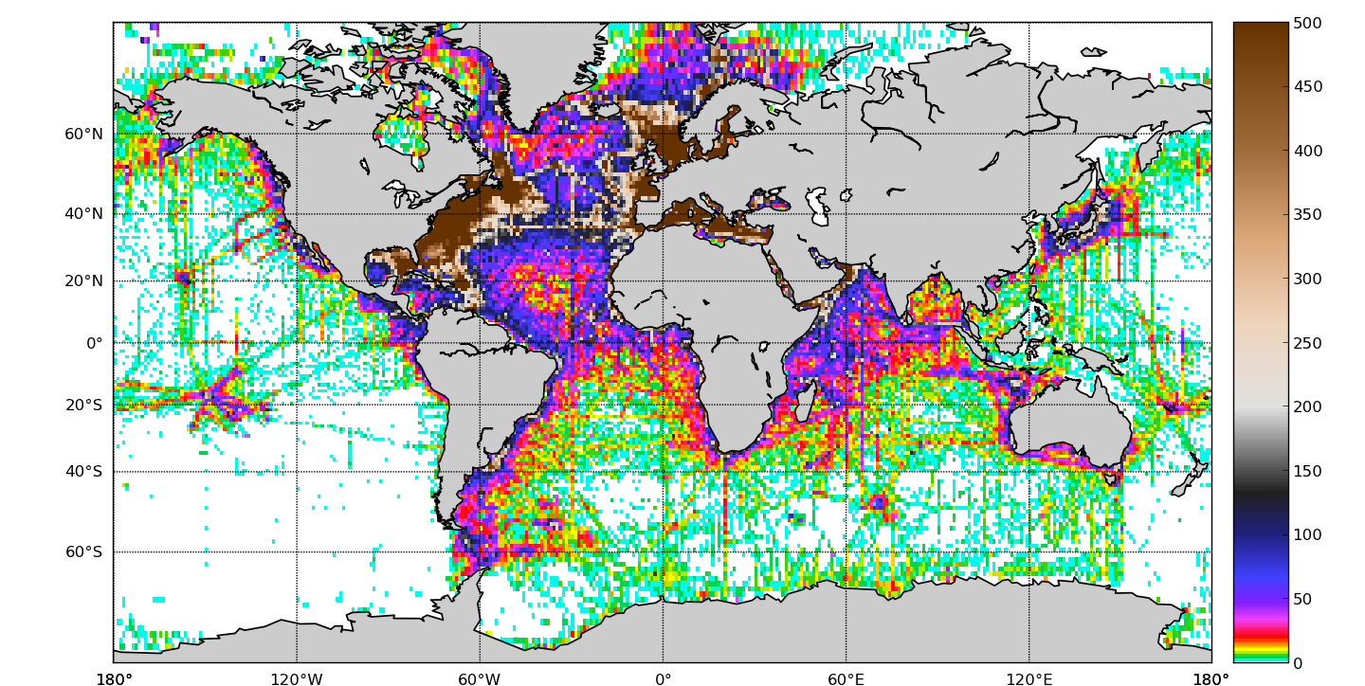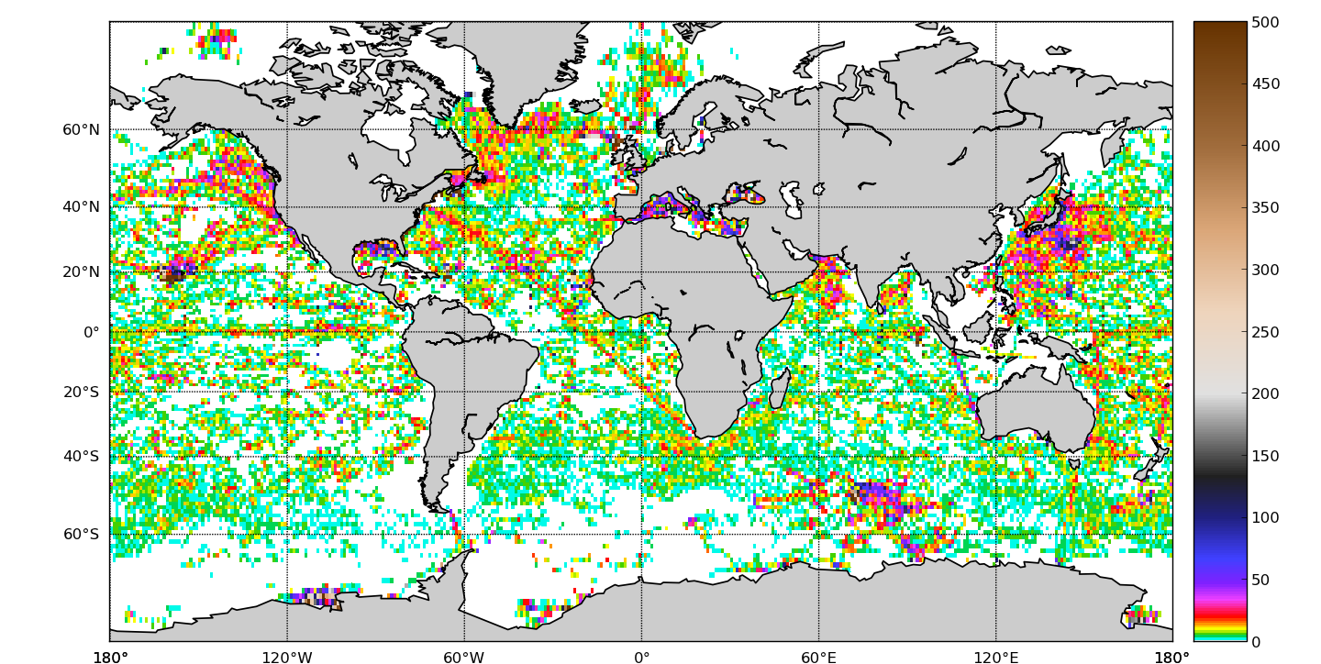
Figure 4: Number of updated profiles per 1°squared cell. SHOM dataset (top) and 2014 dataset (bottom).

The details of the alert test flag and validated is given on Table 1: Delayed time mode validation logs. As anticipated, the basic delayed mode tests (namely, the "Check test", the "Inconsistent date/position test", "Out of range immersion values", "Constant T/S among depth" and "Absurd T/S values") have detected a very small amount of profiles (about 700 profiles out of 3000000, less than 0.03% of the whole validated dataset).
On the other hand, the "Level disorder" test, which aims to detect non monotonous profile pressure field has corrected over 17000 profiles.
The "Duplicated levels" test, which attempts to detect mistakes on the pressure field leading to repeated pressure levels has corrected over 26000 profiles.
Last, over 27000 profiles have been corrected thanks to the "Min/Max" test.

Check test | test description | Corrected profiles number
Inconsistent date test | Check the consistency of the measurement date with the file name | 0
Inconsistent position test | |Lon|≤180 and |Lat| ≤90 | 13
Out of range immersion values | -2.5 db≤Pres ≤ 12000 db | 285
Constant T/S among depth | Constant Temperature or Salinity field | 334
Absurd T/S values | 0<PSAL<46 and -3<TEMP<43 | 94
Level disorder | Check the Press field monotony | 17081
Duplicated levels | Duplicated level evidence | 26015
Min/Max test | Minimum and maximum reference field | 27695
Table 1: Delayed time mode validation logs.
The « Min/Max test » is a comparison of the real time validated temperature and salinity profiles to a minimum and maximum measured values reference field (see IV.7 for details on the method). This field is a gridded mesh of 1 degree resolution horizontal hexagonal cells of 20m depth. The reference fields are the maximum and minimum measured values on a set of 1.2 million ARGO profiles, 30 000 CTD profiles and over 30 0000 sea mammals measured profiles, vertically interpolated from surface to 2000 m depth.
The measurements are compared to the minimum and maximum reference of the corresponding cell and the upper and lower adjacent cells. The profiles containing measurements exceeding the reference values are further controlled by an oceanographer. The Min/Max method is relaxed on the continental shelf since the Min/Max sampling is insufficient in the continental shelf zones. As a consequence, the temperature and salinity profiles measured in the continental shelf (depth<1800m) are compared to a climatology field plus or minus 10 times the climatological standard deviation field.
Figure 5 shows the time repartition of the CORA 4.2 validated profiles, alert profiles and flagged profiles. The validation process has focused on the SHOM dataset prior to 1990 and the year 2014 which represent the main part of the recently uploaded profiles. The wrong profiles detection rate obviously follows the development of modern ocean measurements instruments. Mechanical bathythermograph (MBT) in the 50s and the 60s were obviously not as accurate as modern CTD sensors. Many flagged profiles in the 70s and 80s are related to XBT instrument types with the well documented spiky behaviour when the XBT wire hits the ship hull. The yearly amount of corrected profiles decreases after 1990 with the decreasing number of profiles provided by SHOM..
It is important to note that, since it represents 1.5 million new profiles, the harder part of the work was related to the 2014 dataset. However, the 2014 detection rate is lower than the detection rate prior to 1990.
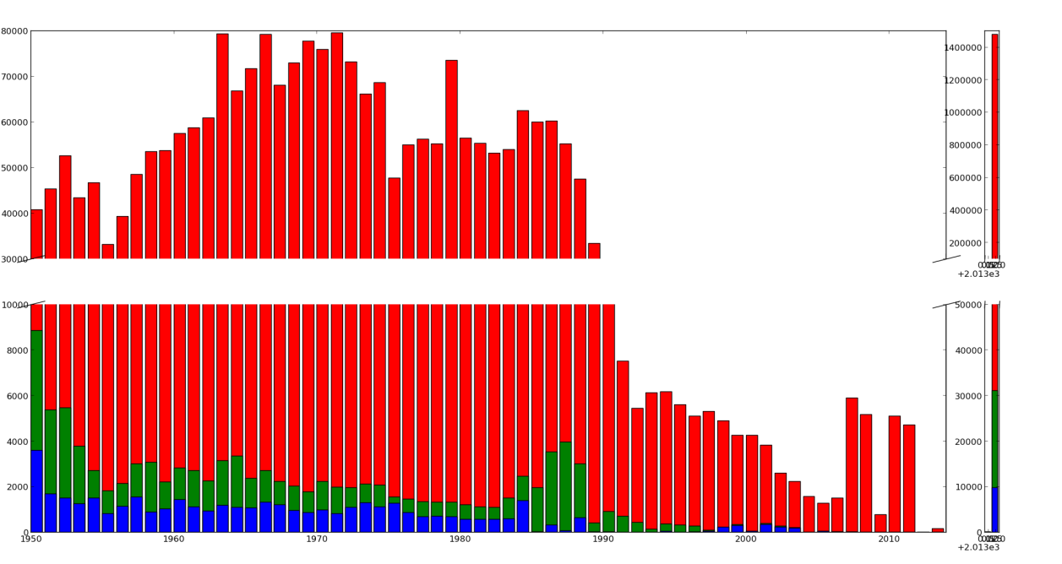
Figure 5: yearly number of validated profiles (red), number of alert profiles (green), number of validated flagged profiles (blue).

Arctic Ocean
In the ARCtic INSTAC component, IMR is in charge of the coordination of the activities and has also the responsibility of the data distribution, quality control and reporting on operational activities as it is foreseen in the contract. IMR is also in charge of providing support to the ARCtic INSTAC users (service desk) and is constantly working on the timely products provision together with the tracking of every process or transaction taking place in the ARCtic INSITU TAC.
The following table summarizes the ARCtic INSTAC activity in terms of NRT service to users and monitoring of the operations.

Data integration
Month | May | June | July | August | September | October | November | December
Number of institutes connected per month since 1st May 2015 | 22 | 19 | 22 | 22 | 24 | 24 | 19
Total Number of platforms integrated per month | 207 | 221 | 229 | 231 | 267 | 257 | 234
Number of Platforms per parameter per month
Temperature | 172 | 180 | 185 | 186 | 223 | 214 | 194
Salinity | 92 | 92 | 91 | 94 | 110 | 95 | 84
Current | 0 | 0 | 3 | 3 | 2 | 1 | 0
BIO | 22 | 22 | 21 | 21 | 22 | 21 | 23
Wave | 0 | 0 | 0 | 0 | 0 | 0 | 0
Other | 96 | 115 | 121 | 117 | 138 | 137 | 133
Service to users
Number of files distributed per month | 1451588 | 138506 | 171708 | 172857 | 203017 | 215978 | 365530 | 117276
Number of single users per month | 6 | 7 | 6 | 5 | 9 | 6 | 5 | 5
Volume downloaded on FTP per month | 6.65GB | 7.75GB | 8.37GB | 7.34GB | 10.25GB | 10.4GB | 14.83GB | 5.09GB

Reliability of the Product Delivery
Product Specification Customer Name  For each product of the CMS Element | Target delivery time  (UTC) | Products delivered late by Target date:time  during the Year 2015  Number of occurrences within the period when the target was not reached | Theorical product updates numbers for year 2015 | Please provide an explanation why target delivery time was not achieved
INSITU_ARC_NRT_OBSERVATIONS_013_031 | 12h daily | 243 | 245
INSITU_ARC_TS_REP_OBSERVATIONS_013_037 | Once a year | N/A | N/A

Incidents/Problems for 2015
CMEMS  N° | Raised  Date | Description | RESP  DU | Status | resolved | comment
3280 | 27/10/2015 | Power failure at IMR on 22th Oct | AR | Closed | 22/10/2015

Baltic Sea
In the BALtic INSTAC component, SMHI is in charge of the coordination of the activities and has also the responsibility of the data distribution, quality control and reporting on operational activities as it is foreseen in the contract. SMHI is also providing support to the Baltic INSTAC users (service desk). SYKE is in charge of the assessment of the historical bio product that is under development under task 3.2. SMHI is constantly working on the timely products provision together with the tracking of every process or transaction taking place in the BALtic INSITU TAC.
The following table summarizes the BALtic INSTAC activity in terms of NRT service to users and monitoring of the operations.

Data integration
Month | May | June | July | August | September | October | November | December
Number of institutes connected per month since 1st May 2015 | 11 | 11 | 10 | 10 | 10 | 10 | 10
Total Number of platforms integrated per month | 150 | 148 | 147 | 145 | 146 | 149 | 149
Number of Platforms per parameter per month
Temperature | 57 | 57 | 55 | 54 | 54 | 57 | 57
Salinity | 10 | 12 | 12 | 11 | 12 | 13 | 13
Current | 5 | 6 | 7 | 5 | 5 | 6 | 6
BIO | 10 | 12 | 12 | 11 | 12 | 13 | 13
Wave | 16 | 15 | 15 | 15 | 15 | 16 | 16
Other | 131 | 132 | 131 | 130 | 130 | 132 | 132
Service to users
Number of files distributed per month | 552007 | 536003 | 580871 | 569124 | 532057 | 410752 | 692802
Number of single users per month | 11 | 12 | 12 | 7 | 14 | 10 | 13
Volume (GB) downloaded on FTP per month | 12.0 | 13.5 | 16.1 | 16.4 | 15.6 | 10.2 | 22.1

Reliability of the Product Delivery
Product Specification Customer Name  For each product of the CMS Element | Target delivery time  (UTC) | Products delivered late by Target date:time  during the Year 2015  Number of occurrences within the period when the target was not reached | Theorical product updates numbers for year 2015 | Please provide an explanation why target delivery time was not achieved
INSITU_BAL_NRT_OBSERVATIONS_013_032 | 12h daily | 0 | 245
INSITU_BAL_TS_REP_OBSERVATIONS_013_038 | Once a year | N/A | N/A

Incidents/Problems for 2015
CMEMS  N° | Raised  Date | Description | RESP  DU | Status | resolved | comment
2556 | 12/03/2015 | Different issues with quality control | BAL | Closed | 04/06/2015
2926 | 2015-07-07 | Missing mooring data in INS-BAL-013-032 | BAL | Resolved | 10//07/2015
3306 | 2015-11-11 | All services from BAL MFC and INSTAC Baltic temporarily unavailable for one hour | BAL | Resolved | 2015/1/2015

NWS
In the NWS INSTAC component, BSH is in charge of the coordination of the activities and has also the responsibility for the data distribution, quality control and reporting on operational activities as it is foreseen in the contract. BSH is also providing support to the NWS INSTAC users (service desk). BSH is constantly working on the timely products provision together with the tracking of every process or transaction taking place in the NWS INSITU TAC.
Data integration
Month | May | June | July | August | September | October | November | December
Number of institutes connected per month since 1st May 2015 | 47 | 50 | 50 | 49 | 49 | 50 | 48
Total Number of platforms integrated per month | 615 | 646 | 620 | 620 | 609 | 659 | 599
Number of Platforms per parameter per month
Temperature | 289 | 312 | 297 | 298 | 289 | 290 | 258
Salinity | 156 | 176 | 162 | 170 | 163 | 166 | 141
Current | 3 | 3 | 2 | 3 | 3 | 3 | 3
BIO | 39 | 46 | 42 | 50 | 46 | 44 | 38
Wave | 281 | 284 | 284 | 281 | 278 | 292 | 296
Other | 159 | 168 | 163 | 164 | 162 | 189 | 164
Service to users
Number of files distributed per month | 768934 | 798757 | 857296 | 985373 | 802759 | 125950 | 1679822
Number of single users per month | 6 | 13 | 12 | 11 | 10 | 6 | 17
Volume downloaded on FTP per month | 22 GB | 45 GB | 26 GB | 65 GB | 32 GB | 4 GB | 71 GB
The following table summarizes the NWS INSTAC activity in terms of NRT service to users and monitoring of the operations.

Reliability of the Product Delivery
Product Specification Customer Name  For each product of the CMS Element | Target delivery time  (UTC) | Products delivered late by Target date:time  during the Year 2015  Number of occurrences within the period when the target was not reached | Theorical product updates numbers for year 2015 | Please provide an explanation why target delivery time was not achieved
INSITU_NWS_NRT_OBSERVATIONS_013_036 | 12h daily | 0 | 245
INSITU_NWS_TS_REP_OBSERVATIONS_013_043 | Once a year | N/A | N/A

Incidents/Problems for 2015
CMEMS  N° | Raised  Date | Description | RESP  DU | Status | resolved | comment
2668 | 13/06/2015 | 30 % Data from North West Shelf Mooring were missing | NO | Closed | 22/06/2015 | Contacted the data provider (DELTARES). Deltares has eliminated the problems on 22/06/2015. Data were reloaded. Monthly files are completed
2917 | 6/07/2015 | Since June 1st we don’t get any wave and river flow data from met.no. | NO | Closed | 18/11/2015 | Contacted the data provider (met.no). met.no has eliminated the problem on 06/11/2015
3400 | 30/11/2015 | Due to an electrical fault, sealevel data are missing from 10/22/2015 to 10/27/2015. | NO | Closed | 30/11/2015 | Data were partially recharged, for some, however, the gaps can still be seen.
3405 | 04/12/2015 | Due to technical issue, the both products were from 02/12/2015 20:00 to 03/12/2015 08:00 unavailable via FPT and WMS services. | NO | Closed | 04/12/2015

IBI
In the IBI INSTAC component, Puertos del Estado (PdE) is in charge of the coordination of the activities and has also the responsibility for the data distribution, reporting on operational activities as it is foreseen in the contract. PdE is also providing support to the IBI INSTAC users (service desk). CNRS is in charge for the assessment and development of improved REP temperature and salinity product. PdE is constantly working on the timely products provision together with the tracking of every process or transaction taking place in the IBI INSITU TAC.
For the maintenance of the IBI INSTAC service that covers operation monitoring, data recovery, process and delivery, some improvements have been done to control the service and improve the product delivery (time adjustments in the synchronization between PUs, improvements in the NetCDF files generator, optimization of the database containing the IBI data, etc).
Concerning the product quality, PdE has worked on BGC quality control: review of RTQC and contact with providers (Instituto Hidrografico, Portugal and IEO, Spain) in order to see the procedures applied at provider level, and to agree in the recovering of data after calibration procedures from providers.
To enhance the completeness of the product, partners reviewed EMODnet reports about parameters and stations in the IBI INSTAC compared with information showed by providers. Some of the reported problems are still under investigation. Actions are planned to follow recommendations raised by EMODnet and finalize a feedback report to EMODnet.
Actions are also taken to add stations measuring waves in particular coastal stations (PdE) in the IBI system measuring SST and waves, but also from more providers (e.g. Marine Institute, Xunta Galicia). New IBI providers were contacted and agreed in the procedure to transfer the new information. It will take some time to have everything ready.
Concerning duplicates between IBI, NWS and GLOBAL, PdE, BSH and Ifremer agreed about distribution of providers in the overlaping areas among the 3 PUs. This action will imply to design modifications in the operational system, to set up a test system and to operate both of them in paralell during the test phase.
We prepared the training course CMEMS IBI User & Training Workshop which was held in Lisbon onDecember 10-11. We attended the workshop and Fernando Manzano gave the training course.
During the period May-December 2015 no incident or problem ocurred in the IBI region. All the products achieved the target date/time.
In the following tables, some statistics about operations in IBI component are displayed.
Statistics related to Service to users are available only from July, due to the fact that only the last 4 month log files are archived in our system. Since then, our system has been adapted and archived log files cover the last 12 months period.

Data integration
Month | May |  | June | July | August |  |  | September |  |  | October |  | November |  | December
Number of institutes connected per month since 1st May 2015 | 47 |  | 49 | 47 | 44 |  |  | 47 |  |  | 47 |  | 43 |  | 41
Total Number of platforms integrated per month | 793 |  | 796 | 794 | 771 |  |  | 756 |  |  | 747 |  | 683 |  | 596
Number of Platforms per parameter per month
Temperature |  | 545 | 544 | 544 |  | 530 |  |  | 513 |  | 512 |  | 487 |  | 412
Salinity |  | 304 | 312 | 311 |  | 300 |  |  | 294 |  | 299 |  | 288 |  | 22
Current |  | 26 | 25 | 25 |  | 20 |  |  | 20 |  | 19 |  | 20 |  | 21
BIO |  | 56 | 58 | 59 |  | 53 |  |  | 56 |  | 53 |  | 42 |  | 30
Wave |  | 60 | 60 | 58 |  | 58 |  |  | 60 |  | 63 |  | 53 |  | 53
Other |  | 380 | 378 | 384 |  | 387 |  |  | 387 |  | 379 |  | 329 |  | 299
Service to users
Number of files distributed per month |  |  |  | 1948291 |  |  | 1870745 |  |  | 1728529 |  | 1882052 |  | 1746775 | 1845584
Number of single users per month |  |  |  | 9 |  |  | 10 |  |  | 11 |  | 10 |  | 15 | 17
Volume downloaded on FTP per month |  |  |  | 67.1 Gb |  |  | 78.3 Gb |  |  | 72.5 Gb |  | 59.3 Gb |  | 107.9 Gb | 58.9 Gb

Reliability of the Product Delivery
Product Specification Customer Name  For each product of the CMS Element | Target delivery time  (UTC) | Products delivered late by Target date:time  during the Year 2015  Number of occurrences within the period when the target was not reached | Theorical product updates numbers for year 2015 | Please provide an explanation why target delivery time was not achieved
INSITU_IBI_NRT_OBSERVATIONS_013_033 | 12h daily | 0 | 245
INSITU_IBI_TS_REP_OBSERVATIONS_013_040 | Once a year | N/A | N/A

Incidents/Problems for 2015
CMEMS  N° | Raised  Date | Description | RESP  DU | Status | resolved | comment

Mediterranean Sea
In the MED INSTAC component, HCMR is in charge for the coordination of the activities and has also the responsibility of the data distribution, reporting on operational activities as it is foreseen in the contract. HCMR is also in charge of providing support to the MED INSTAC users (service desk). OGS is in charge for the assessment and development of improved REP temperature and salinity product. HCMR is constantly working on the timely products provision together with the tracking of every process or transaction taking place in the MED INSITU TAC. By the end of this year, HCMR is expecting to finalise the setup of the Icinga monitoring platform in collaboration with IFREMER. The objective is to monitor the status of Global DU (primary monitor service) and all the other DUs and products if an alert is raised from the Global DU (downtime, failure to deliver product on time).
Concerning the new platforms integration process, HCMR is constantly trying to communicate with new data providers. During the last months, the available data capacity has been extended through the aggregation of SOCIB’s fixed stations (15), while by the end of this year three more fixed stations from the Slovenian Environmental Agency are expected to be integrated in the Med In situ TAC data base. Moreover, the Mediterranean V2 dataset was received from SeaDataNet during last July and the first check and process of the data has already been done. A lot of work and effort is needed in order to integrate the whole dataset in the CMEMS MED INSTAC portal. Consequently this task will be finalised in 2016.
Regarding the INSTAC meetings held during the previous months, HCMR participated to the first INSTAC plenary meeting, which took place in Brussels (EuroGOOS office) on December 23-24, where the status of the MED component was presented. HCMR also participated to the CMEMS user and training workshop for the Mediterranean Sea which was held in La Spezia, Italy (December 3-4), by preparing the training material and giving the training courses in collaboration with SOCIB (Antonis Chalkiopoulos from HCMR and Charles Troupin from SOCIB).
During the period May-December 2015, two incidents were identified:
- A problem with the Oceanotron visualization tool that didn’t display all the data correctly and the data from thermo-salinometers were missing. This problem occurred during September and it affected only the viewing tool and not the product in general.
- A network outage at HCMR due to technical problems (broken fiber channel as we were informed by our ISP) caused the unavailability of the Mediterranean In Situ TAC products from 14/10/2015 08:30 UTC to 15/10/2015 07:00 UTC. The visualization tool (Oceanotron - WMS service) was also unreachable from 14/10/2015 08:30 UTC to 15/10/2015 14:15 UTC.
In the following tables, some statistics referring to the MED component operations during the period May-December 2015.

Data integration
Month | May | June | July | August | September | October |  | November | December
Number of institutes connected per month since 1st May 2015 | 25 | 25 | 26 | 25 | 25 | 26 |  | 25 | 25
Total Number of platforms integrated per month | 172 | 166 | 169 | 157 | 151 | 167 |  | 160 | 158
Number of Platforms per parameter per month
Temperature | 137 | 132 | 137 | 125 | 123 | 121 | 121 |  | 121
Salinity | 113 | 109 | 110 | 108 | 106 | 102 | 104 |  | 98
Current | 20 | 20 | 19 | 13 | 17 | 18 | 18 |  | 15
BIO | 42 | 33 | 35 | 31 | 35 | 35 | 33 |  | 29
Wave | 15 | 14 | 13 | 11 | 15 | 17 | 15 |  | 13
Other | 50 | 47 | 50 | 45 | 48 | 61 | 52 |  | 42
Service to users
Number of files distributed per month | 74472 | 76606 | 73852 | 86764 | 301241 | 64153 | 60097 |  | 78983
Number of single users per month | 14 | 23 | 20 | 15 | 16 | 20 | 20 |  | 21
Volume downloaded on FTP per month (GB) | 10.31 | 7.23 | 6.69 | 15.68 | 51.04 | 5.44 | 4.50 |  | 18.92

Reliability of the Product Delivery
Product Specification Customer Name  For each product of the CMS Element | Target delivery time  (UTC) | Products delivered late by Target date:time  during the Year 2015  Number of occurrences within the period when the target was not reached | Theorical product updates numbers for year 2015 | Please provide an explanation why target delivery time was not achieved
INSITU_MED_NRT_OBSERVATIONS_013_035 | 12h daily | 244 | 245
INSITU_MED_TS_REP_OBSERVATIONS_013_041 | Once a year | N/A | N/A

Incidents/Problems for 2015
CMEMS  N° | Raised  Date | Description | RESP  DU | Status | resolved | comment
3069 | 01/09/2015 | Viewing issue with INS_MED_NRT_OBS_013_035 and thermo-salinometers | MED | Closed | 23/09/2015
3209 | 14/10/2015 | Network failure at HCMR | MED | Closed | 15/10/2015

Black Sea
In the Black Sea INSTAC component, IOBAS is in charge of the coordination of the activities and has also the responsibility for the data distribution, quality control and reporting on operational activities as it is foreseen in the contract. IOBAS is also in charge of providing support to the Black Sea INSTAC users (service desk). IOBAS is constantly working on the timely products provision together with the tracking of every process or transaction taking place in the Black Sea INSITU TAC.
The following table summarizes the Black Sea INSTAC activity in terms of NRT service to users and monitoring of the operations.

Data integration
Month | May | June | July | August | September | October | November | December
Number of institutes connected per month since 1st May 2015 | 4 | 4 | 4 | 4 | 4 | 4 | 4 | 4
Total Number of platforms integrated per month | 19 | 20 | 20 | 21 | 23 | 20 | 19
Number of Platforms per parameter per month
Temperature | 17 | 17 | 17 | 18 | 20 | 18 | 16
Salinity | 15 | 15 | 15 | 16 | 18 | 16 | 14
Current | 0 | 0 | 0 | 3 | 3 | 3 | 3
BIO | 4 | 5 | 6 | 9 | 9 | 9 | 8
Wave | 4 | 5 | 5 | 5 | 5 | 4 | 4
Other | 0 | 0 | 0 | 3 | 3 | 3 | 3
Service to users
Number of files distributed per month | 14202 | 82510 | 116622 | 109045 | 95166 | 101364 | 104596
Number of single users per month | 5 | 7 | 6 | 4 | 3 | 7 | 8
Volume (Gb) downloaded on FTP per month | 0.7 Gb | 2.8 Gb | 2.9 Gb | 2.3 Gb | 2.28 Gb | 2.4 Gb | 2.7 Gb

Reliability of the Product Delivery
Product Specification Customer Name  For each product of the CMS Element | Target delivery time  (UTC) | Products delivered late by Target date:time  during the Year 2015  Number of occurrences within the period when the target was not reached | Theorical product updates numbers for year 2015 | Please provide an explanation why target delivery time was not achieved
INSITU_BS_NRT_OBSERVATIONS_013_034 | 12h daily | 244 | 245
INSITU_BS_TS_REP_OBSERVATIONS_013_042 | Once a year | N/A | N/A

Incidents/Problems for 2015
CMEMS  N° | Raised  Date | Description | RESP  DU | Status | resolved | comment
2688 | 02/05/2015 | INSITU_BS_NRT_OBSERVATIONS_013_034  was not accessible due to ISP Network failure | BS | Closed | 02/05/2015
2788 |  | INS-IOBAS-BS-TS-NRT-OBS_POINTSERIES_LATEST  INS-IOBAS-BS-TS-NRT-OBS_PROFILE_LATEST  INS-IOBAS-BS-TS-NRT-OBS_TRAJECTORIES_LATEST  were not accessible due to internal server error. | BS | Closed | 05/06/2015
2820 | 15/06/2015 | INSITU_BS_NRT_OBSERVATIONS_013_034  were not accessible due to ISP Network failure | BS | Closed | 16/06/2015
2915 | 07/07/2015 | INSITU_BS_NRT_OBSERVATIONS_013_034  was not accessible due to ISP network maintenance | BS | Closed | 07/07/2015
3292 | 08/11/2015 | INSITU_BS_NRT_OBSERVATIONS_013_034  was not accessible due to server failure. | BS | Closed | 09/11/2015
2688 | 02/05/2015 | INSITU_BS_NRT_OBSERVATIONS_013_034  was not accessible due to ISP Network failure | BS | Closed | 02/05/2015

TASK 3 SYSTEM EVOLUTION
This part of the INSTAC AAR is dedicated to service evolution activities that are undertaken under the TASK3 of the contract. The activity is reported for each of the sub-tasks that have been identified in the INSTAC proposal [DA2]. At the end of 2015, the activity is progressing as planned and deviations from the initial plan are for the time being foreseen.

Toward the creation of a CMEMS temperature and salinity database with the best features of EN.4 and CORA (Task 3.1.1)
The CORA dataset is a delayed time mode validated in situ temperature and salinity dataset. A distinct dataset with similar goals, EN.4, has been elaborated by the UK-MetOffice. This task aims to provide a single product combining the best features of CORA and EN.4 datasets.
The main challenge of this work is first to identify profiles provided by both datasets and unique profiles provided by each of the products. The number of duplicated profiles plus the unique profiles provided by EN,4 and CORA4.2 gives an estimation of the number of profiles that will be provided by the CMEMS merged product. A comparison of the two products has been performed in order to detect the duplicated profiles and to assess the number of profiles in the merged dataset.
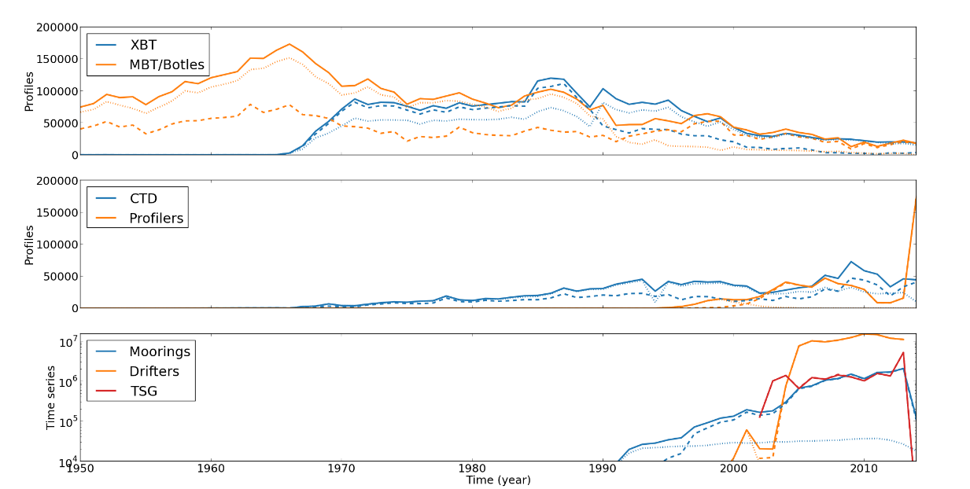
Figure 6: Estimation of profiles provided by the CORA 4.2 dataset (dashed lines), the EN.4 (doted lines) and total amount of unique profiles (bold lines).

An estimate of the number of profiles available in a CMEMS product by merging EN.4 and CORA4.2 and eliminating the duplicated profiles is given on Figure 6. The profiles are sorted by eight raw probe types for a better understanding. An increase of 75% of the number of CORA profiles is attempted from the dataset merging, mostly because of the increased number of mechanical bathythermographs profiles before 1990. The total number of XBTs and CTDs also slightly increase. A global increase of 30% of the number of EN.4 profiles is attempted from the dataset merging.
Figure 6, gives the estimation of the number of profiles measured by moorings, drifters and embedded thermo-salinographs. The is-situ measurements time series providing is an area of interest of the CORA dataset, so most of the attempted CMEMS time series are attempted to be taken from the CORA dataset.

Current REP product (Task 3.1.2)
The general objective of this task is to provide a new multi-year ocean surface current dataset for the global ocean and the “01/01/1990-present Year-2” period.
The main objective of the year 2015 was to prepare the 1990-2014 dataset and associated documentation (PUM & QUID) to be delivered for CMEMS V2. The following tasks have been performed so far:
- download of all surface drifters data as distributed by the Surface Drifter Data Assembly Centre (SD-DAC at NOAA AOML) for the 1990-2014 period,
- download of wind stress observations from ERA-INTERIM product for the 1990-2014 periods,
- download of altimeter observations (L4 multi-mission product) for the 1990-2014 periods,
- calculation of direct wind slippage correction from each drifting buoy velocities following the method developed by Rio, 2012 and using a new Ekman model developed as part of the GlobCurrent ESA project (Rio et al., 2014),
- preparation of sample files (one file per platform) in NetCDF format,
- interaction with Ifremer DU for the validation of the sample files,
- writing of the Product User Manual,
- writing of the Quality Information Document.
Figure 7 and Figure 8 illustrate the content of the Current REP product.
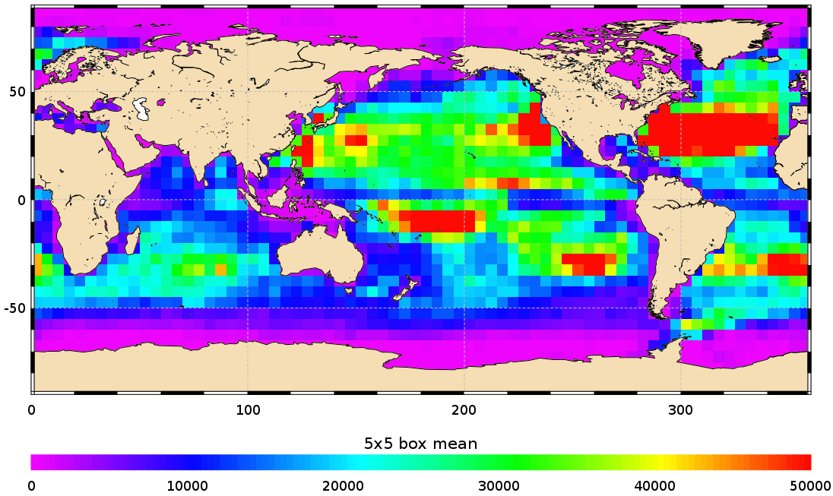
Figure 7: Number of ocean surface current measurements for the 01-01-1990 to 31-12-2014 period, in 5°x5° boxes

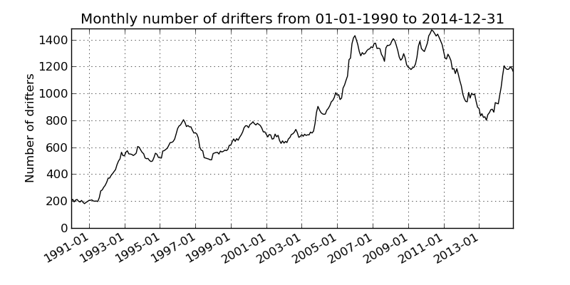 | 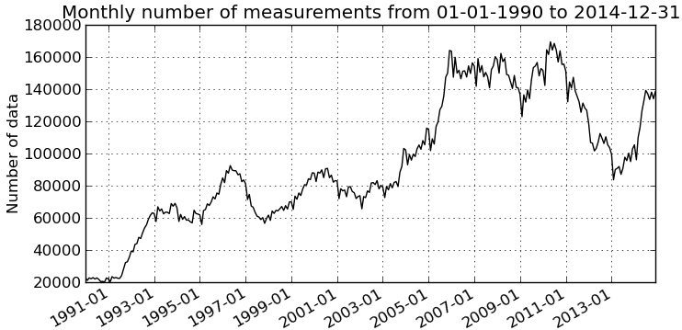
Figure 8: Monthly number of drifters (left) and of ocean surface current measurements (right) for the 01-01-1990 to 31-12-2014 period

References
Rio, M.-H. (2012), Use of altimeter and wind data to detect the anomalous loss of SVP-type drifter’s drogue, J. Atmos. Oceanic Technol., 29, 1663–1674, doi:10.1175/JTECH-D-12-00008.1.
Rio, M.-H., S. Mulet, and N. Picot (2014), Beyond GOCE for the ocean circulation estimate: Synergetic use of altimetry, gravimetry, and in situ data provides new insight into geostrophic and Ekman currents, Geophys. Res. Lett., 41, doi:10.1002/2014GL061773.

T&S Regional REP product (Task 3.1.3 )
The general aims are:
- To develop a common extended approach to quality assure the regionally multi-year data sets by implementing the metrics to be agreed within the Product Quality Working Group (PQWG) for the multi-year products as well as developing regional reference fields.
- To define regional key observation sites and transects for the operational comparison with the MFC outputs.

To advance along these lines, the needs have been analysed and discussed on a 2 weeks basis between the IMR and SOCIB teams, and between them and the INSTAC group in the first CMEMS INSTAC plenary meeting in Brussels (September, 23rd-24th, 2015). Also relevant were the discussion at the CMEMS Marine Environment Monitoring Service Workshop (Sept. 7th -8th, 2015, Joaquin Tintore (SOCIB), Emma Heslop (SOCIB) and Henning Wehde (IMR) attending), and with Mercator (e.g., meeting PQWG-MYP in Toulouse in October 2015 (Charles Troupin (SOCIB), Jerome Gourrion (IFREMER) and Vidar Lien (IMR, also associated to the Arctic MFC participating and webex conference with partners and led by Karina von Schuckmann, OSR-TT in November, Joaquin Tintore (SOCIB) and Vidar Lien (IMR) attending).

The focus is established on the importance to work with trusted sources and to develop regional climatologies. Given the present situation on these two topics, the second point from the general aim seems essential and is detailed below as 2016 plan. The main topics for 2016 are:
- Development of generic tools for quality control (in progress) and their implementation in the regions (planned in 2016).
- Enhancement or development of regional climatologies to improve the definition of reliable data obtained by a better range formulation for the regions (planned in 2016).
- Definition of key sections for the operational comparison with the MFC outputs (transects with long time series and with dynamical and/or biological relevance have been proposed: Ibiza Channel, Barents Sea, Baltic Sea)
- Regional integrated quantities (eg. heat content, mixed layer depth)
- Validation and analysis at various spatial and temporal scales, from regional to coastal and local scales (under discussion with all the concerned groups)

Developing historical REP Bio product (Task 3.2 )
A general review of existing BGC data in existing portals (EMODnet, EEA, ICES , EuroGOOS ROOS, CMEMS-INSTAC) has been performed per parameter. This is summarized in the following sections.

EMODnet

Phosphate
Period 1990-1999
Baltic  31952 records | Mediterranean region  19351 records | North-East Atlantic (40 W) 23841 records
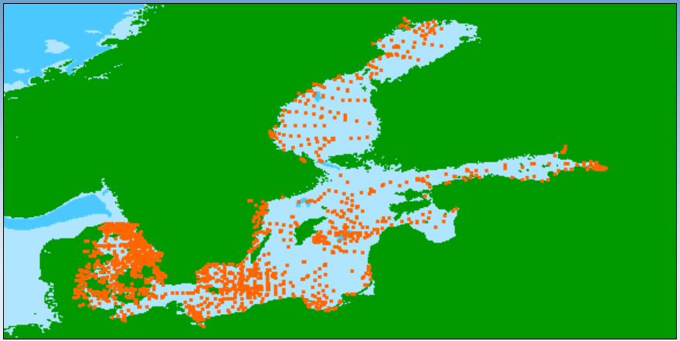 | 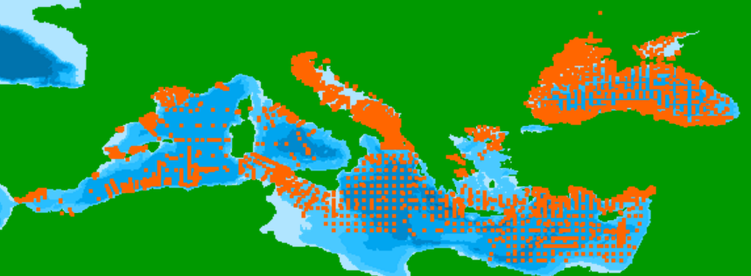 | 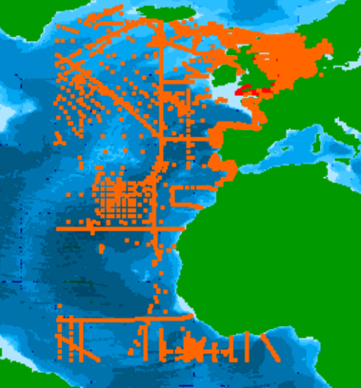
Period 2000-2015
Baltic  49280 records | Mediterranean region  23152 records | North-East Atlantic (40 W)  47476 records
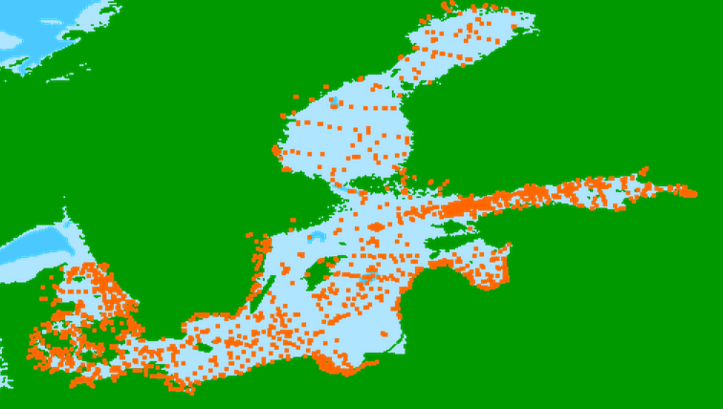 | 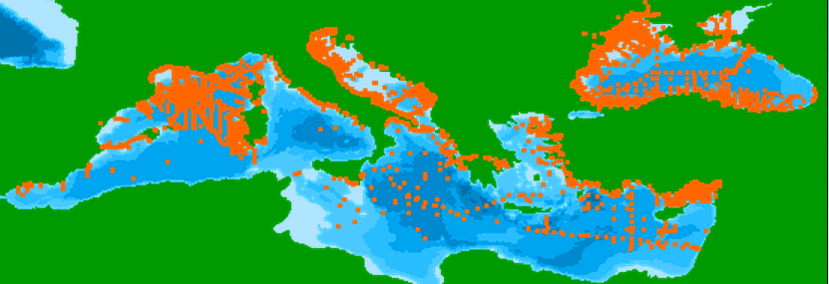 | 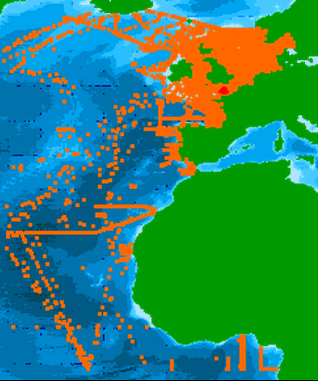

Nitrate
Period 1990-1999
Baltic  31504 records | Mediterranean region  18590 records | North-East Atlantic
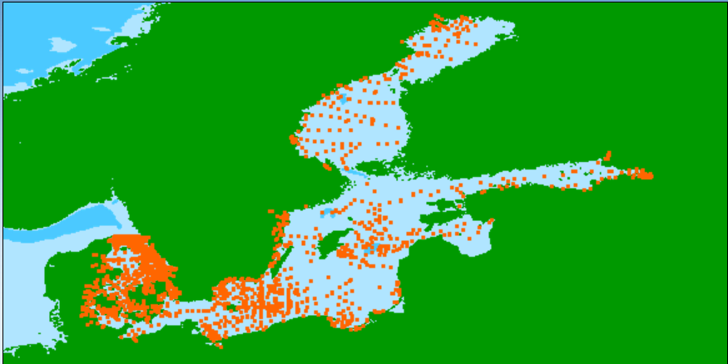 | 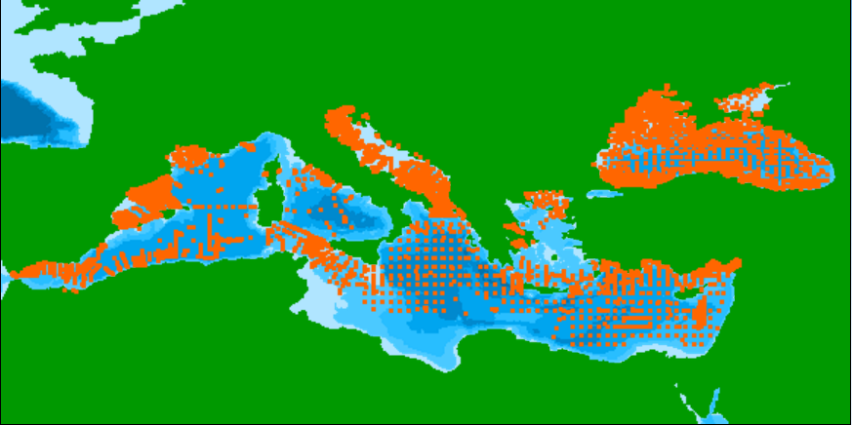 | 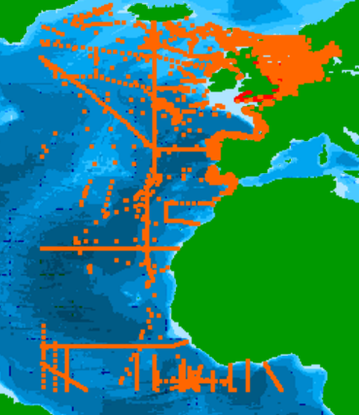
Period 2000-2015
Baltic  24743 records | Mediterranean region  19934 records | North-East Atlantic  47243 records
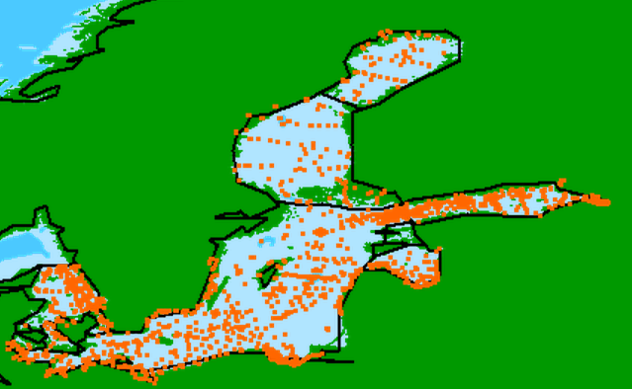 | 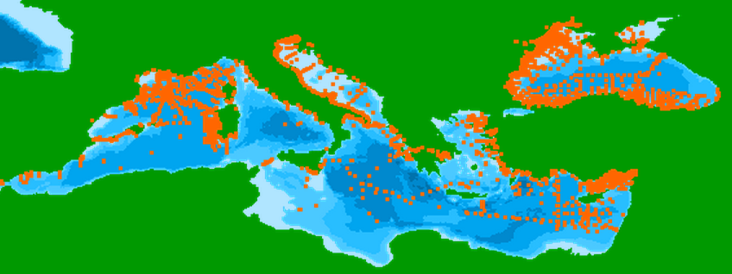 | 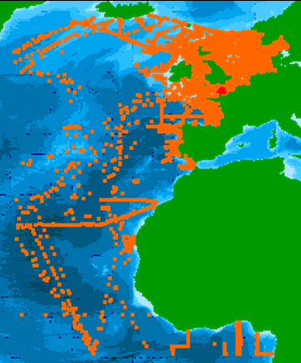

Ammonium concentration parameters in the water column

Period 1990-1999
Baltic  27439 records | Mediterranean region  11871 records |  | North-East Atlantic  15151 records
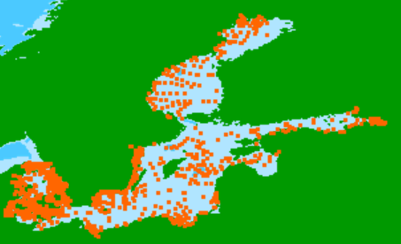 | 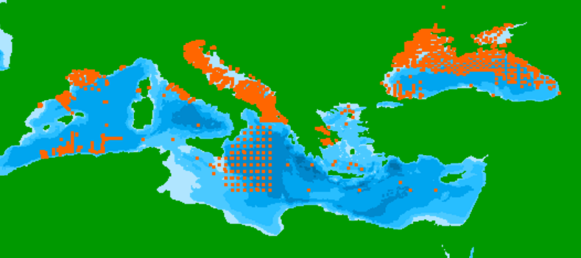 |  | 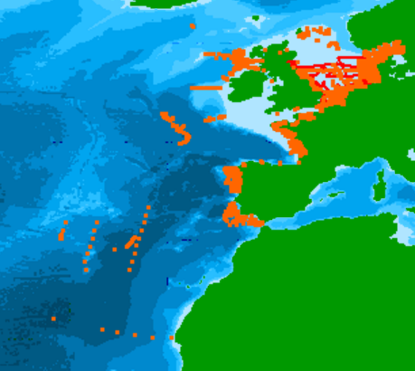
Period 2000-2015
Baltic  43254 records |  | Mediterranean region  23252 records |  | North-East Atlantic  34901 records
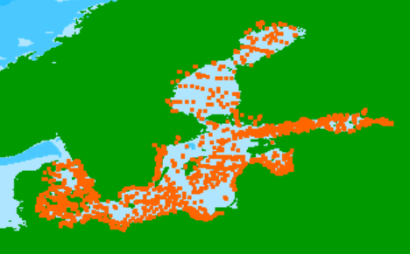 |  | 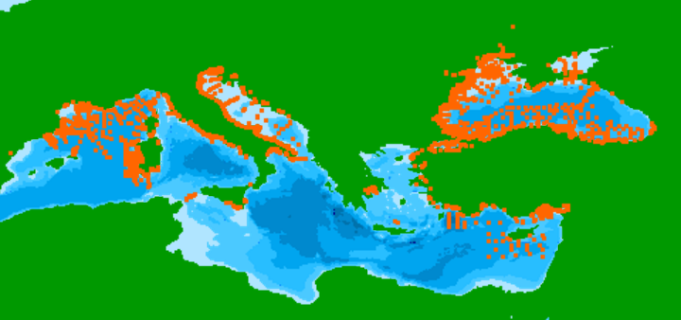 |  | 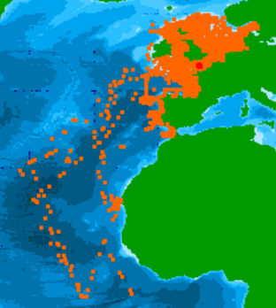

Chlorophyll-a

Period 1990-1999
Baltic  25635 records |  | Mediterranean region  7425 records |  | North-East Atlantic  20386 records
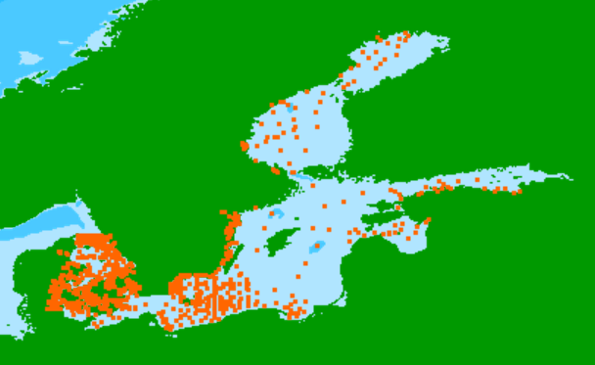 |  | 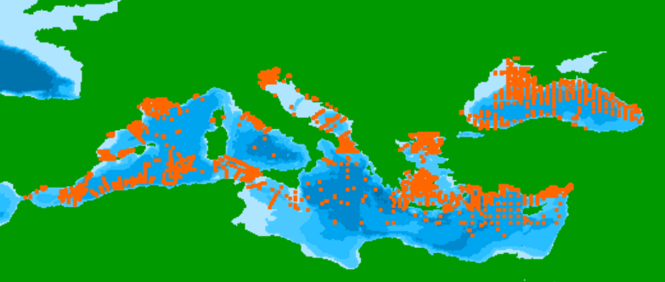 |  | 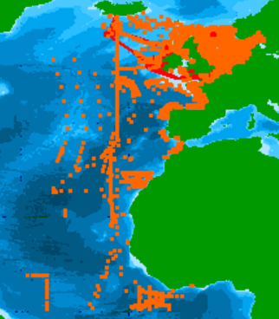
Period 2000-2015
Baltic  38297 records | Mediterranean region  2196 records |  | North-East Atlantic  41946 records
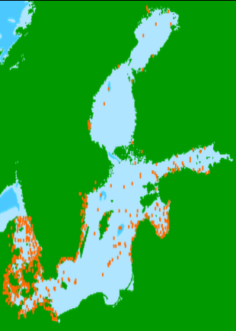 | 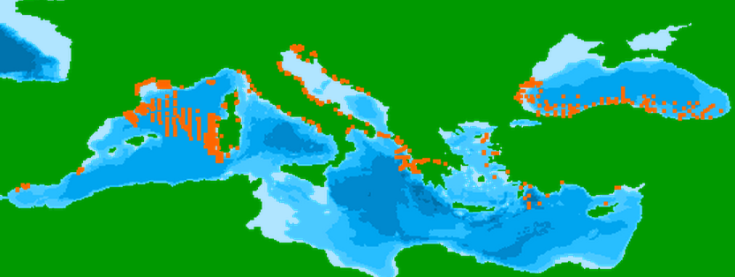 |  | 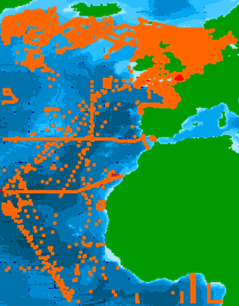

EEA
EEA provides data for chlorophyll-a concentrations demonstrating chlorophyll distribution with map for 2012 data. Eutrophication trends are showed as charts. The original data is available, but unfortunately coordinates for all data are not available. EEA Waterbase contains timely, reliable and policy-relevant data collected from EEA member countries through the WISE-SoE data collection (formerly known as Eionet-Water and Eurowaternet) process.

Chlorophyll
See this link for more information.
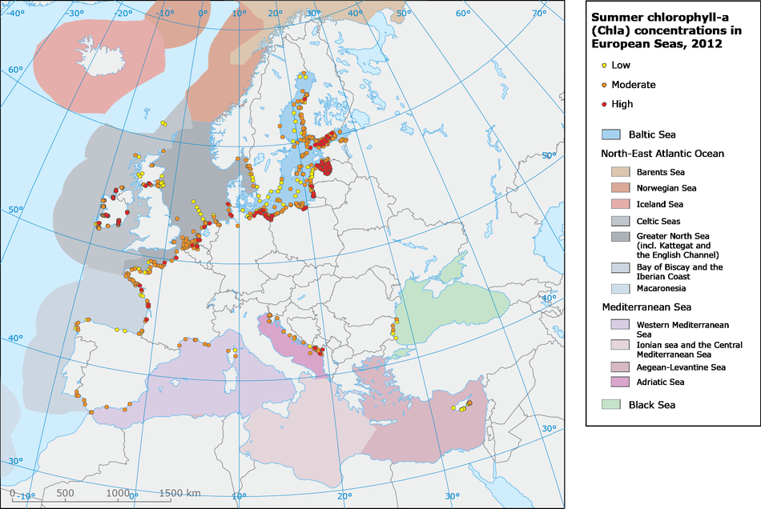

Dissolved inorganic nitrogen
See this link for more information.

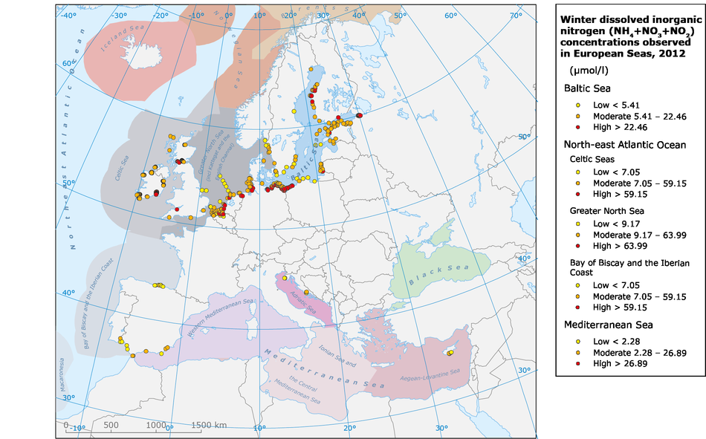

ICES
ICES chlorophyll and nutrient data is available in ASCII format from the portal (see http://ocean.ices.dk). The maximum number of stations per download is 20000 for Bottle and low resolution CTD stations and 5000 for high resolution CTD stations. If this limit doesn't fulfill the user’s requirements, one may request data by submitting the following information to ocean@ices.dk

- Time Period
- Latitude/Longitude limits
- Parameters. Standard parameters are Temperature, Salinity, Oxygen, Phosphate, Total Phosphorus, Silicate, Nitrate, Nitrite, Ammonium, Total Nitrogen, Hydrogen Sulphide, pH, Alkalinity and Chlorophyll a.
- Observation depths (e.g. surface/bottom/profile/high resolution CTD)
- Processed data including gridded products (specify grid interval and depth interval). Although we may not have all products at present, we are most interested in knowing your needs.
- Intended use of the data.

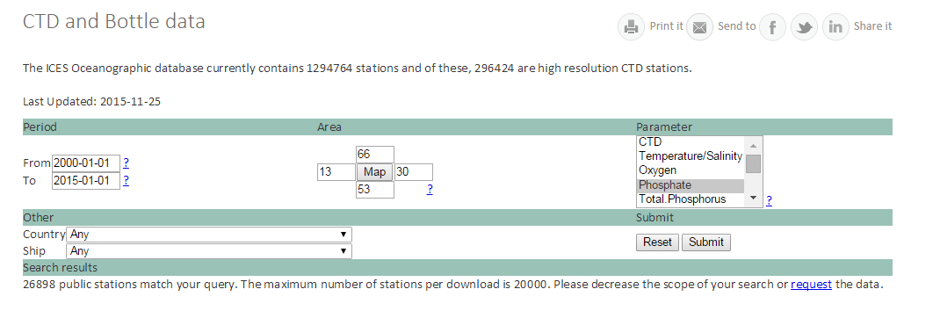

HELCOM

 | Chlorophyll 75946 records for the years 2000-2015
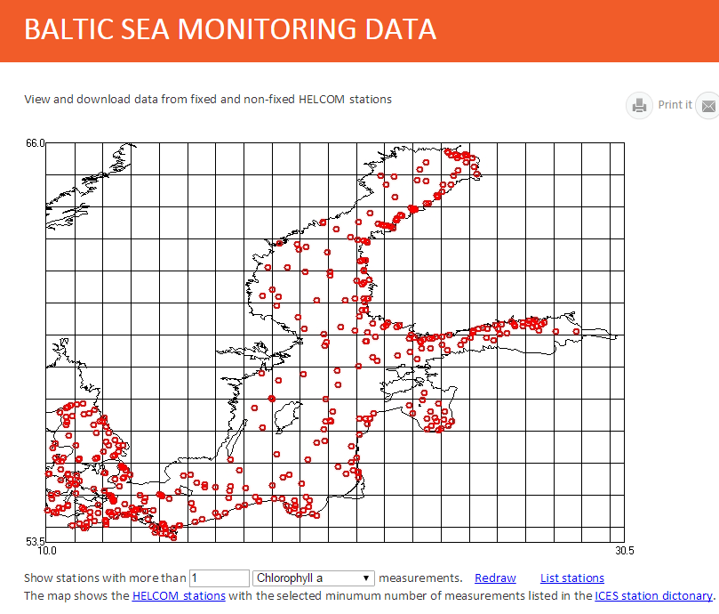 | 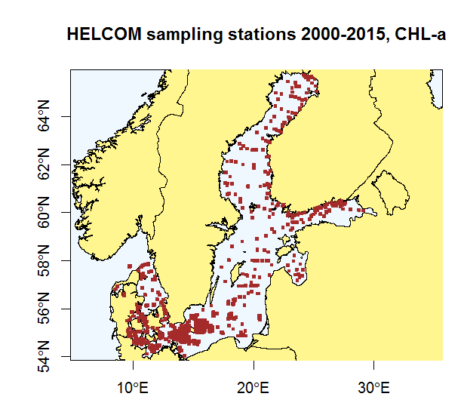
Phosphate records 136855 for the years 2000-2015  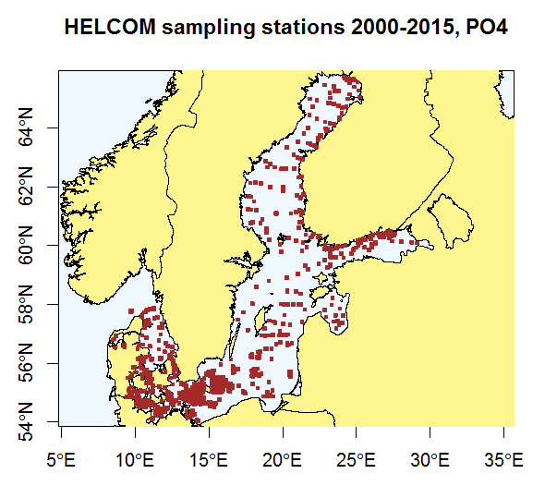 | Nitrate records 136855 for the years 2000-2015  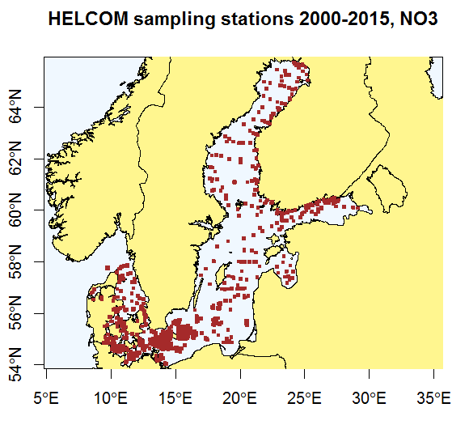

The Baltic Environmental Database.
The hydrography and chemistry data are available for everybody on the Internet via the applications Das (http://nest.su.se/das/) and Nest (http://nest.su.se/nest/)- an information environment for decision support system with the exception of the 5 last years.
NEST also allows to access the River loads, Atmospheric nitrogen and phosphorus deposition, and Point Sources to the Baltic Sea datasets.
To access these restricted data the user must get permission of the data contributor. In this case the user shall contact us Christoph Humborg or Miguel Rodriguez Medina in order to get information on the data sources and contact persons.
The user that has been granted access is expected to include the data sources in the acknowledgements on any publication.

Ferrybox online data
Ferrybox online data is available in various sources. First of all online data is available in the Copernicus Marine Environment Service. Also regional providers display their current observations on their own web pages. For example:
SYKE Alg@line | http://www.jarviwiki.fi/wiki/Alg@line
Estonia marine Institute. MS Viktoria | http://www.sea.ee/keskkonna-info-2/ferrybox-4/
Marine Systems Institute, MS Baltic Queen | http://ferrybox.msi.ttu.ee/

Bio-ARGO
There was also a discussion about Bio-ARGO and the concepts that could be reused and applied in this activity. Common payload in Bio-ARGO are CDOM, Chla, BBp(700), Eds(l) and PAR. In addition, some floats have support for Cp(660), NO3 and O2. The currently quality controlled data from 109 floats has been partly used for OC matchups and strengthens the task to be performed in this task.
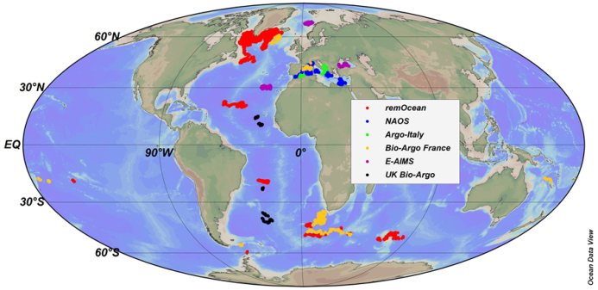 | 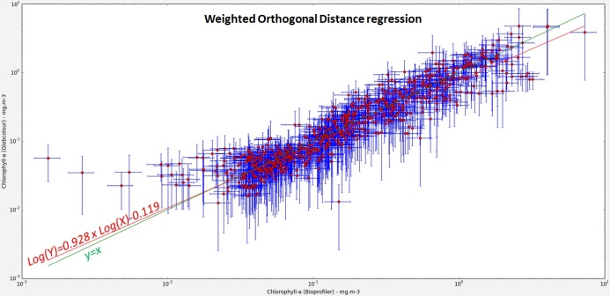

The link between OCTAC and INSTAC activities has been managed by taking part in meetings and workshops on both TACs. Current outcome from this work has been the two sided feature of the link..

Status at CMEMS INSTAC and future work
A review on parameters and units used within the CMEMS portal has been carried out. Results are presented in the figures below. They illustrate the parameter codes used on the portal and their occurrence.
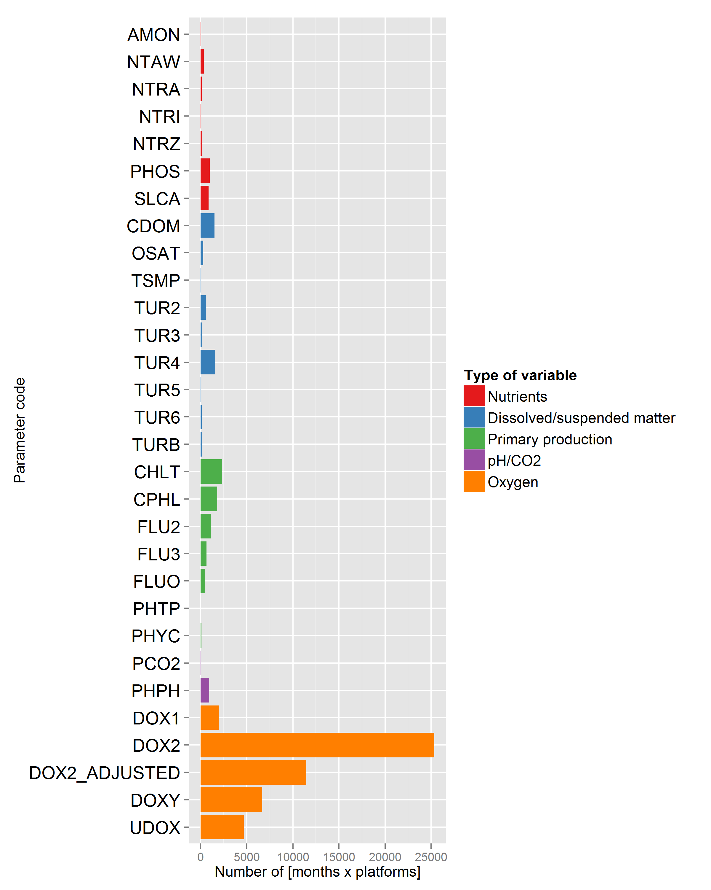 | 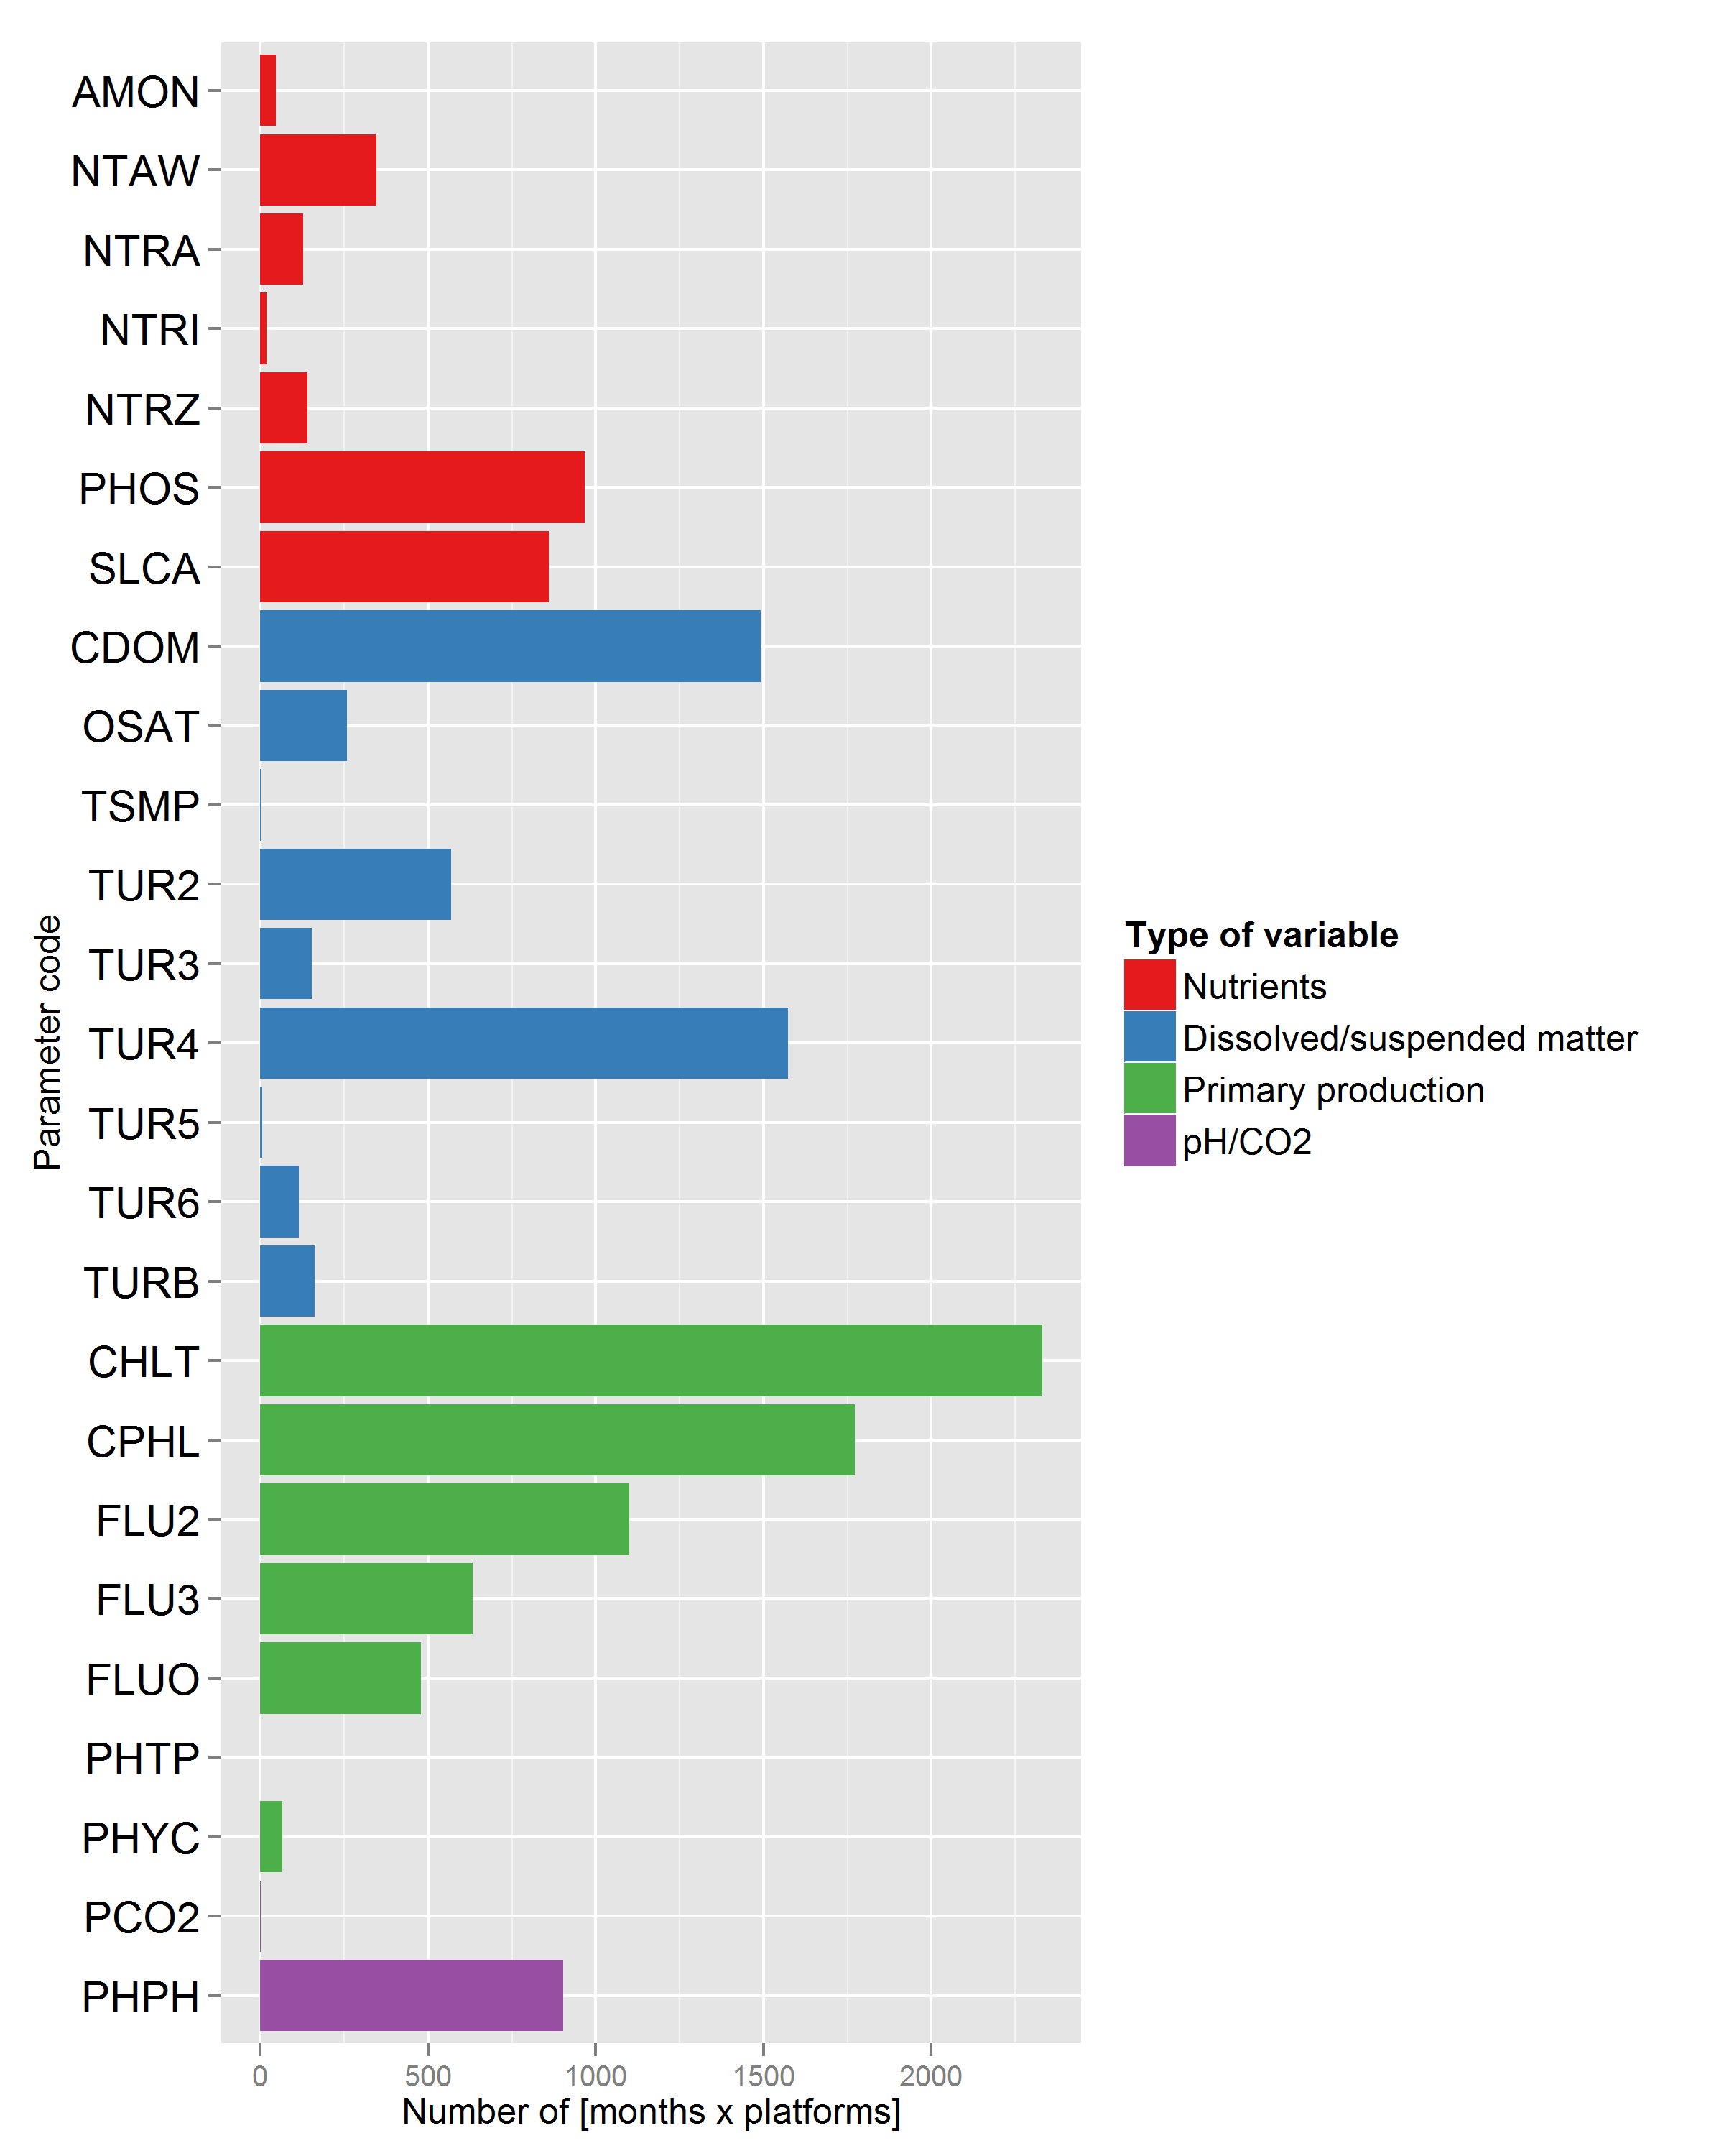
Number of files per parameter and per platform from index monthly file. On the right, without oxygen.
The following table shows the different names and units used for the Chl-a related parameters, and show clearly the need for standardization of reporting

varname | par_unit | par_longname
FLU2 | milligram/m3 | Fluorescence
FLU2 | mg/m3 | CHLOROPHYLL_A_FLUORESCENCE
FLU2 | mg/m3 | fluorescence
FLU2 | relative unit | fluorescence_of_chlorophyll_A
FLU3 | FFU | Fluorescence
FLUO | relative unit | Fluorescence
FLUO | milligram/m3 | Sea Point Fluorescence
CPHL | milligram/m3 | Total chlorophyll-a
CPHL | volts | Total chlorophyll-a
CPHL | ug/l | Total chlorophyll-a
CPHL | milligram/m3 | Chlorophyll-a total
CPHL | mg/l | CHLOROPHYLL-A_TOTAL

Reviewing portals and keeping QC methods in mind lead to the basic information for standardization of parameters and their units. Results also show how QC methods should be prioritized according to the parameters occurrences. The group has already started working on a corrected list for names, units and additional meta information to be provided to CMEMS. A recommendation document will be provided to the DU early 2016 in order to help them gather and distribute the correct information for BGC measurements. These recommendations will also form the base requirements for the further quality controls developed.

Developing NRT and Historical Wave product (Task 3.3)
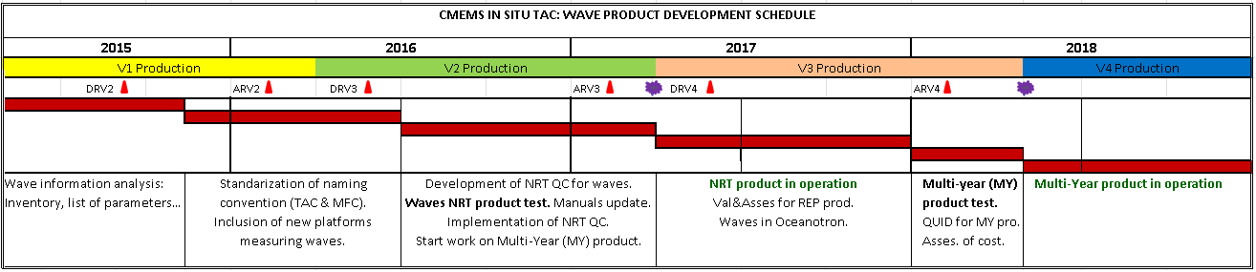
The general objective in this task is to generate the CMEMS INSTAC wave products (NRT and REP). In the MyOcean project suite, Wave was not a parameter that was in the MyOcean catalogue. There were requirements to integrate wave data in some EUROGOOS/ROOSs and as the In-Situ portal was operated jointly with MyOcean, waves have been integrated "by chance" in the INSTAC distribution but with little harmonization on the parameters and metadata names and with no monitoring on the parameters that were included and no associated documentation. In CMS Wave products are now considered, which implies operational procedures with a level of completeness and of quality of the Wave products that need to be respected. In this contract we propose to first develop the near real-time product and harmonize the data management of such product and in a second step to move towards a multi-year product for Wave. The planned schedule for Wave product is the following:
Figure 9 : Planned schedule for Wave products development.

Here we show the planned activities for the period 1st May 2015 - 31st Dec 2015. All of them have been finalized.
- Inventory of existing wave info within INSTAC: Reviews of all index files per DU to compile what wave parameters are distributed. (HCMR).
In order to identify the wave platforms in every INSTAC component, all the index files used in the CMEMS FTPs in the INSTAC components (regional and global DUs) have been downloaded and examined carefully.
In the following table and figure we show the platforms measuring waves.

REGION | WAVE PLATFORMS (TOTAL) | WAVE PLATFORMS (ACTIVE*)
Arctic-ROOS | 95 | 37
Baltic Sea, BOOS | 19 | 12
Black Sea | 0 | 0
Global Ocean | 658 | 217
Iberia-Biscay-Ireland, IBI-ROOS | 206 | 71
Mediterranean Sea, MOON | 60 | 26
North West Shelf, NOOS | 218 | 119
Table 2 : Number of platforms measuring wave parameters in each regional DU. (Active*: at least one transmission in the last 30 days). The tests were performed on 28.07.2015.

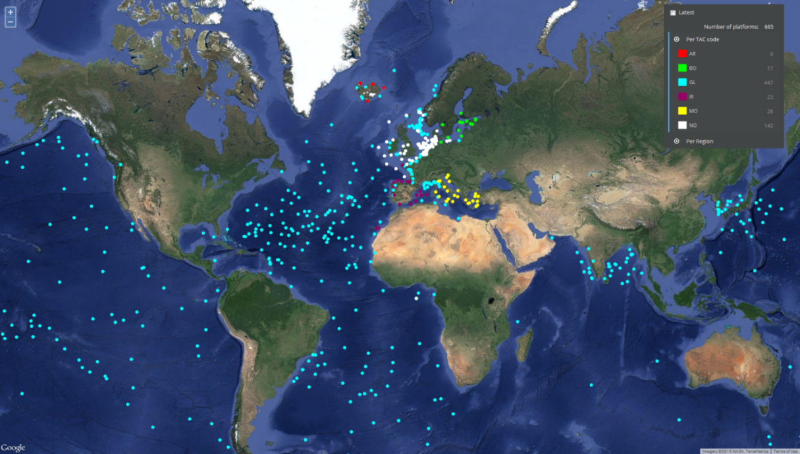
Figure 10 : Platforms measuring wave parameters (Active & Historical)
It’s important to note that in the table above we found several platforms duplicated and shown in several DUs with different files generated by different components.
We have started an action on duplicates in order to choose a component (Regional or Global) responsible for every provider. This way, users will find a unique file for every platform.
- Review EMODnet and regional portals (if available) to list wave info not included in INSTAC. (HCMR)
EMODnet indexes waves and wind parameters together under the category “Waves and Wind”, therefore the list that was extracted from the portal (http://www.emodnet-physics.eu/Map/) contained platforms with both parameters. The processing of the list revealed 500 platform codes that contained wind and wave measurements, while the actual number of the wave platforms (taking out wind-only recording stations) is limited to 257 in total, a number which is significantly lower than the 665 platforms found in all DUs. This great discrepancy in the wave platform numbers between the CMEMS In Situ TACs and the EMODnet is quite surprising, since a synchronization process is known that has been established between these two infrastructures. A cross check between the EMODnet and the In Situ TAC lists, resulted to 6 wave platforms that are present in the EMODnet portal and not in the In Situ TACs.
The list of wave and wind parameters with their description and units that are included in EMODnet portal can be found in the following link http://www.emodnet-physics.eu/portal/user-s-guide. Some of the parameters used are not present in In-Situ TAC or they are expressed in different abbreviations.
- Contact with regional providers to see what wave data and stations can be added, being careful with coastal stations very much affected by local effects. To be discussed if we plan to include all the wave available information in Europe (collaboration of all DUs).

We have contacted with regional providers to add more wave information:

- In BOOS region, stations from Finnish Meteorological Institute (FMI) were added after the summer break.
- In IBI region, in the following months wave coastal stations will be added from Puertos del Estado, Marine Institute and Xunta de Galicia.
- Buoy wave data from CEFAS will be integrated in NWS, IBI and Global DUs trough BSH (NWS DU)
- In the Mediterranean, wave data from SOCIB and Slovenian Environmental Agency buoys will be integrated in the MED DU during the next two months

This activity will continue during the following months.

- Analysis of the Global Ocean Wave information: Integration of NDBC wave data and Ifremer to analyze with the Globwave people at Ifremer to identify the other outside EUROPE providers we should connect to. (Ifremer)

Ifremer has performed the analysis of the Global Ocean Wave Information and results were presents in the the Kick-Off In Situ TAC meeting in Brussels (22-24 September 2015):

On Global DU level, January – September 2015
- 298 platforms with wave related parameters, from 27 institutions
- 21 wave parameters

- Review all NetCDF parameters related to waves in order to find the most appropriate ones to be assigned to the parameters provided. (PdE)

PdE performed a first version of the list of wave parameters, classifying them by type of parameter (height, period, direction) and specifying the analysis performed in every one.
An updated version was compiled by HCMR after the review of all DUs index files (find it below). The new list contains the parameters already provided by PdE with the addition of some extra parameters that have been found during the processing of index files. Shaded background corresponds to the most common ones (parameters that can be found in more than 30 platforms).
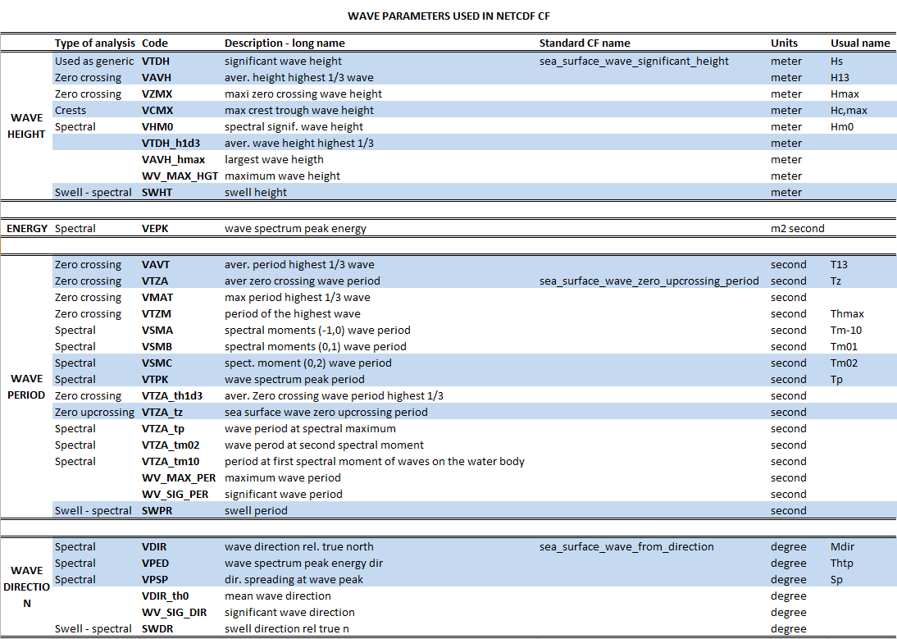
Table 3: List of wave parameters used in NetCDF (shaded blue background corresponds to the most common ones).
- Determination of wave parameters to be included. (PdE, HCMR, SMHI, IFREMER).

Once the other activities have been finished, we have started the determination of wave parameters to be included in CMEMS INSTAC wave products.

Starting from the parameters list done in activity 5 (Table 3), the wave team has proposed some modifications:
- Elimination of the repeated or meaningless parameters.
- Inclusion of new “generic” parameter names for the case we don’t know the estimator used.
- Inclusion of new parameters that can be distributed and are not included in NetCDF reference lists.
- Proposal of new standard CF names for those parameters without it.

In the following table it’s shown the table with the modifications proposed. These changes and updates are important and are going to affect the wave international community. We are participating in the CMEMS wave working group where we will discuss this list of parameters and the way to validate it. Probably, we will have to open the discussion that has to be collegial (such as what is done for cfconventions.org: mailing list open to everybody, discussions->validation->update of source document).

WAVE PARAMETERS IN NETCDF CF
 | Type of analysis | Code | Description - long name | Standard CF name | Units | Usual name
WAVE HEIGHT | Used as generic | VTDH | significant wave height | sea_surface_wave_significant_height | meter | Hs
 | Zero crossing | VAVH | aver. height highest 1/3 wave | sea_surface_zero_crossing_significant_wave_height | meter | H13
 | Zero crossing | VZMX | maxi zero crossing wave height | sea_surface_zero_crossing_maximum_wave_height | meter | Hmax
 | Crests | VCMX | max crest trough wave height | sea_surface_crest_trough_maximum_wave_height | meter | Hc,max
 | Spectral | VHM0 | spectral signif. wave height | sea_surface_spectral_significant_wave_height | meter | Hm0
 | Swell - spectral | SWHT | swell height | sea_surface_swell_wave_significant_height | meter
 | "= VAVH" | VTDH_h1de | aver. height highest 1/3 wave | ELIMINATE | meter
 | "= VZMX" | VAVH_hmax | largest wave height |  | meter
 | "= VCMX" | VMXL | Height of the highest crest |  | meter
 | "= VZMX" | WV_MAX_HGT | maximum wave height |  | meter
NEW | Generic | VGHS | generic significant wave height (unknown estimator) | sea_surface_generic_significant_wave_height | meter | Hs
 | Zero crossing | VHZA | aver. zero crossing wave height | sea_surface_zero_crossing_averaged_wave_height | meter | Hzm
 | Zero crossing | VH10 | aver. height highest 1/10 wave | sea_surface_zero_crossing_averaged_one_tenth_wave_height | meter | H1/10
 | Crests | VMNL | Depth of the deepest trough | deepest_trough_depth | meter
 | Estimation | VEMH | estimated maximum wave height | sea_surface_estimated_maximum_wave_height | meter
ENERGY | Spectral | VEPK | wave spectrum peak energy | sea_surface_wave_spectrum_peak_energy | m2 second
WAVE PERIOD | Zero crossing | VAVT | aver. period highest 1/3 wave | sea_surface_zero_crossing_significant_wave_period | second | T13
 | Zero crossing | VTZA | aver zero crossing wave period | sea_surface_wave_zero_upcrossing_period | second | Tz
 | Zero crossing | VMAT | max period highest 1/3 wave |  | second
 | Zero crossing | VTZM | period of the highest wave | sea_surface_zero_crossing_highest_wave_period | second | Thmax
 | Spectral | VSMA | spectral moments (-1,0) wave period | sea_surface_wave_mean_period_spectral_inverse_frequency_moment | second | Tm-10
 | Spectral | VSMB | spectral moments (0,1) wave period | sea_surface_wave_mean_period_spectral_first_frequency_moment | second | Tm01
 | Spectral | VSMC | spect. moment (0,2) wave period | sea_surface_wave_mean_period_spectral_second_frequency_moment | second | Tm02
 | Spectral | VTPK | wave spectrum peak period | sea_surface_wave_period_at_spectral_density_maximum | second | Tp
 | Swell - spectral | SWPR | swell period | sea_surface_swell_wave_period | second
 | "= VTZA" | VTZA_th1d3 | aver. zero crossing wave period highest 1/3 wave | ELIMINATE
 | "= VTZA" | VTZA_tz | sea surface wave zero upcrossing period
 | "= VTPK" | VTZA_tp | wave period at spectral maximum
 | "= VSMC" | VTZA_tm02 | wave period at second spectral moment
 | "= VSMB" | VTZA_tm10 | period at first spectral moment of waves on the water body
 | "= VTMX (NEW)" | WV_MAX_PER | maximum wave period
 | "= VAVH" | WV_SIG_PER | significant wave period
NEW | Generic | VGTA | generic averaged wave period | sea_surface_generic_averaged_wave_period | second
 | Zero crossing | VT10 | aver. period highest 1/10 wave | sea_surface_zero_crossing_averaged_one_tenth_wave_period | second | T1/10
 | Zero crossing | VTMX | maximum wave period | sea_surface_zero_crossing_maximum_wave_period | second | Tmax
WAVE DIRECTION | Spectral | VDIR | wave direction rel. true north | sea_surface_wave_from_direction | degree | Mdir
 | Spectral | VPED | wave spectrum peak energy dir | sea_surface_wave_from_direction_at_spectral_peak | degree | Thtp
 | Spectral | VPSP | dir. spreading at wave peak | sea_surface_wave_directional_spreading_at_spectral_peak | degree | Sp-Ds
 | Swell - spectral | SWDR | swell direction rel true n | sea_surface_swell_wave_to_direction | degree
 | "= VMDR (NEW)" | VDIR_th0 | mean wave direction
 |  | WV_SIG_DIR | significant wave direction
NEW | Spectral | VMDR | mean wave direction | sea_surface_wave_from_mean_direction | degree | Mdir
WAVE STEEPNESS | Generic | VST1 | Maximum wave steepness | maximum_wave_steepness | unit less
Table 4 : Proposal for wave parameters in NetCDF. Green font corresponds to new entries; red font indicates items to be eliminated.

The table above is focused to integrated parameters. Wave measurements can also provide spectral information, but it is more complicated to deal with than parameters. The wave team has decided to open a parallel working line to work on spectral information. We are still on progress, and we have compiled in the following table the spectral usual information. This wave spectral information will be discussed also in the CMEMS wave working group.
SPECTRAL INSITU WAVE INFORMATION
 | Type of analysis | Code | Description - long name | Standard CF name | Units | Usual name
FREQUENCY | Spectral | CENTRALFREQ | central frequency | central_frequency | Hz
 | Spectral | BINFRQRANGE | frequency range of indiviudal bin | bin_range_frequency | Hz
 | Spectral | BANDWIDTHFREQ | bandwidth of the frequency bin | band_width_frequency | Hz | df(f)
 | Spectral | BINLOWFRQ | lower frequency of indiviudal bin | bin_lower_frequency | Hz
 | Spectral | LCF$ | Low frequency cut-off for wave spectra, calculated from the dispersion relation | low_frequency_cutoff | Hz
ENERGY | Spectral | THETA1 | mean wave direction |  | degree | th1(f)
 | Spectral | THETA2 | principal wave direction |  | degree | th2(f)
 | Spectral | STHETA1 | directional spread of the entire sea state in degrees |  | degree | sigma1(f)
 | Spectral | STHETA2 | directional spread of waves at the peak frequency in degrees |  | degree | sigma2(f)
 | Spectral | EFWV | wave variance spectral density | sea_surface_variance_spectral_density | m2 second | S(f)
Table 5: Spectral information used in Real Time.

Improving the Interface with CIS(Task 3.4.1)
This task has been in a standby mode in 2015 as no activities were planned within the CIS to improve in-situ product viewing and downloading through the CIS until late 2015. The focus has therefore been put on correcting anomalies on the configuration set up within MyOcean to reach an homogeneous implementation for all the INSTAC DU
Enhancements dealing with improvement of performances with big datasets and adding new features (SOS subsetting) are under development within CIS to provide the V1.3.5 of Oceanotron. The deployment will be decided with Mercator and CLS that managed the CIS. Regional DUs requirement is to have the same Oceanotron version deployed both for SeaDataNet and CMEMS projects.

Improving Interfaces with MCF (Black List) (Task 3.4.2)
This task is located at the interface between INSTAC and MFCs. The problem concerned by this task is first addressed on a global scope and in the context of delayed-time products.
INSTAC provides in-situ datasets qualified through an extensive list of consistency tests. Quality information included on the products allows discarding data upon a user-defined quality criterion. On its side, and sequentially, the global MFC runs a qualification procedure that turns in rejecting a subset of data that will not be fed into the assimilation system. Here, the result may be constituted both of erroneous data (that INSTAC let go through its system) and good quality data associated to physical processes that are not resolved by the model physics. A critical point is the difficulty to assess the rejection motive, either data quality or model capacity to digest it.

On both sides, the quality of the qualification procedures may impact severely the adequacy of rejecting such or such specific data. Cabanes et al. (2013) provides an example for year 1998 where up to 30 % of the measurements rejected by the MFC procedure were confirmed to be erroneous data, see their paragraph 3.2.2 Up to now, the efficiency of the qualification procedures implemented at INSTAC has not allowed to analyse in detail the other 70 % (following the above example).
In parallel and internally, INSTAC has been recently working on the qualification methodologies in the context of its delayed-time production (see section III.1.1 relative to the latest CORA release). The approach relaxes strong statistical assumptions on the local parameter distribution, allowing the simultaneous optimization of the number of good detection and false alarms. It relies on historical estimates of local minimum and maximum parameter values, in addition to the usual mean and standard deviation fields. Following the remarks raised in the previous paragraph, it has been decided, jointly between CORIOLIS R&D and MERCATOR validation teams, to modify the task working plan in order to take advantage of the recent methodological developments conducted at CORIOLIS R&D and intent to apply it to the T/S innovations from an homogeneous time series of the MERCATOR outputs.
While already implemented at INSTAC for the delayed-time T/S production, the new statistical approach requires specific work before evaluation and possible implementation in the MFC system. Essentially, an historical model innovation dataset must be analysed and used to derive the required statistical parameters. Presently, discussions have permitted to identify the GLORYS2-V3 dataset as suitable for such use; it was provided in November by MERCATOR facility to CORIOLIS R&D. Analysis of the dataset will start in early 2016. In parallel with a longer term objective, studies will be conducted to anticipate application of the method in real-time quality control procedures and for regional systems.

Min/Max approach, principles and early validation results
This approach claims to be a step beyond the classical approach in automatic anomaly detection through local comparison to an historical dataset; “classical approach” referring to evaluating a validity interval 1) centred on the local climatological mean, 2) wide as 2N times the local standard deviation and 3) using a constant N value for all locations.
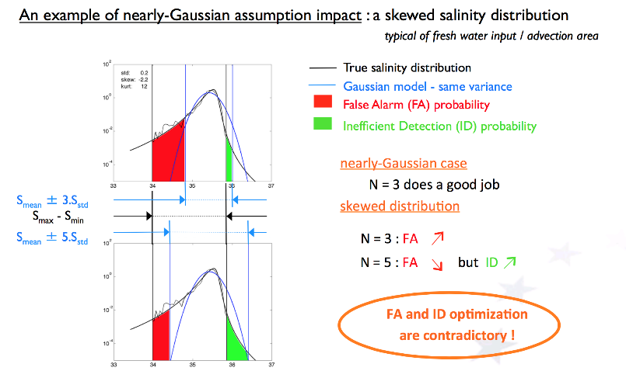
Figure 11 : Comparison of climatological test efficiency compared to Min/max method
Figure 11 compares both methods in a case of skewed salinity distribution near the ocean surface in the close neighbourhood of a specific location. The black curves stand for the true (thin) and modelled (thicker) distributions, while vertical black bars locate the actual minimum and maximum observed values. The blue bell-shaped curve corresponds to the Gaussian distribution with same mean and variance as the true one. Blue vertical bars indicate the boundaries of the validity interval as assumed by the classical mean/std approach when using 3 (5) as a value for N in the upper (lower) diagram.
This figure evidences that, in the classical approach, the assumed validity interval may be both shifted and stretched relatively to the true one, depending on the value chosen for N. The horizontal extent of the red patch illustrates the range of salinity values where good data are evaluated as out of range, i.e. false alarms occur. Inversely, the green patch indicates the range of salinity values where erroneous data are not detectable e.g. the detection is inefficient. It is understood that tuning N parameter value does not permit reducing simultaneously the numbers of false alarms and inefficient detections; only a trade-off between both inaccuracy sources may be found.
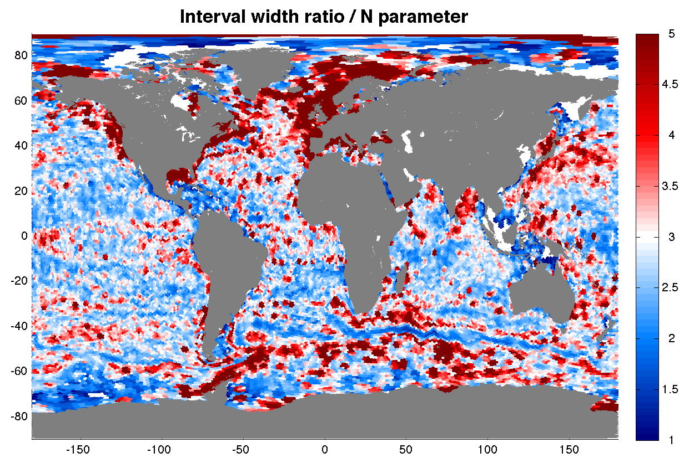 | 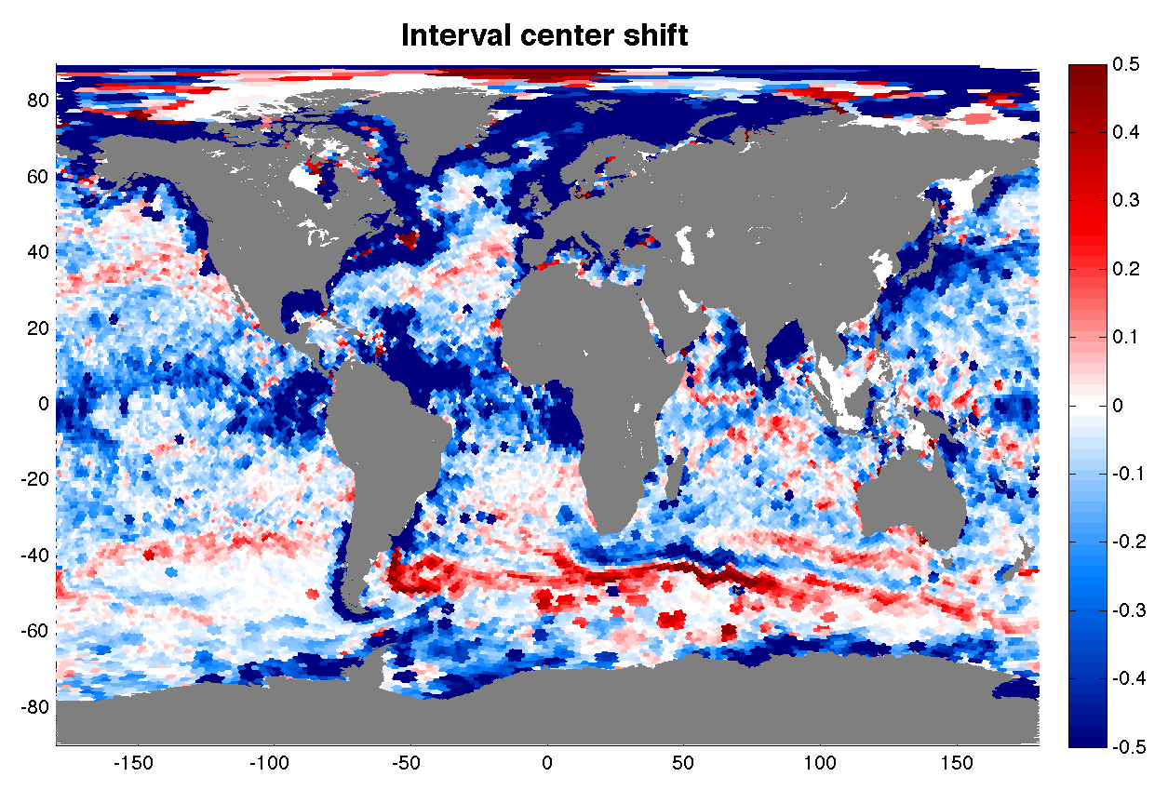
Figure 12: left panel, shows the validity interval centre shift estimated as the difference between the centre of the Min/Max interval and the mean value from the same historical dataset , right panel shows the validity interval width ratio or effective N parameter estimated as the ratio of the Min/Max interval width to twice the standard deviation.
As a further illustration of the method impact, Figure 12, left panel, shows the validity interval centre shift estimated as the difference between the centre of the Min/Max interval and the mean value from the same historical dataset while right panel shows the validity interval width ratio or effective N parameter estimated as the ratio of the Min/Max interval width to twice the standard deviation. Recalling that the classical approach assumes that the distribution is symmetric and N is homogeneous, Figure 12 illustrates all the spatial statistical variability that is not accounted for, leading to high heterogeneity in the performance of the classical detection, while the Min/Max approach naturally accounts for such spatial variations of the distribution shape.
Finally, both methods are compared in terms of efficiency of “good” and “wrong” detections. A subset of profiler data from year 2012 is used, and the delayed-time quality control result obtained in building CORA 4.2 is used as truth. Both methods are run and percentages of efficiency are computed for “good” and “wrong” detections. The classical method was run for a large set of N parameter values.
The results are shown in Figure 13. Red curves refer to the Min/Max approach (independent of N), blue curves to the classical one. For each colour, the set of curves correspond to 12 monthly statistics. It is clear that a single value for N does not allow reaching the same percentage of “good” and “wrong” detections: for N = 4, the percentage of good detections is equivalent (~25%) but the that of wrong detections is twice higher; for N = 5, the percentage of wrong detections is similar but that of good detections significantly reduced.
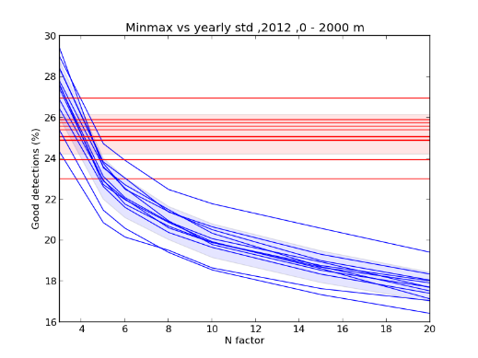 | 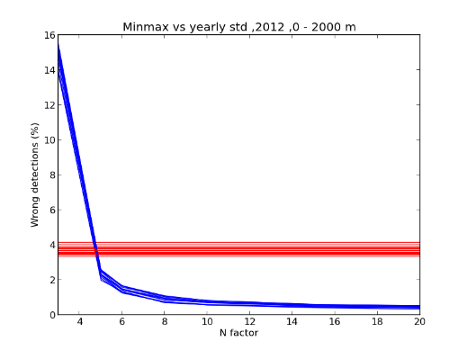
Figure 13: Comparison of the two method efficiency
The Min/Max approach allows to better account for variability in the distribution shape when detecting erroneous data from a local comparison to historical dataset. As a result, both “good” and “wrong” detections can be optimized simultaneously, avoiding the choice of an empirical parameter N that, in the classical approach, is only the result of a trade-off between high level of good detections and low level of wrong detections.

Provider uptake and Link with EMODNet and EEA: EuroGOOS (Task 3.4.3 )
EuroGOOS has been working with its members and with the ROOSes to enable access to new platforms (see maps hereafter):
- Finland (SYKE, FMI) :Access to 12 tide gauges, 7 buoys, 3 RT, 4 delayed mode,1 profiling float, 1 Argo, 1 ferrybox
- Sweden (SMHI): 5 buoys (real time data) and 4 Bottom mounted systems (delayed mode data), data from 5 icebreakers. SMHI now provides data from 1978 onwards from all platforms if/where data available
- Estonia (MSI): 1 buoy, 1 ferrybox
- Spain (Socib): 29 platforms, tide gauges, moorings, Argo, HF Radar
- Bulgaria/Romania: 3 buoys in the Black Sea managed by IOBAS

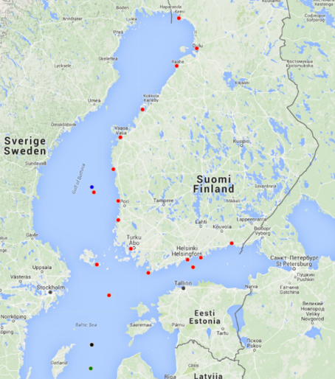 | 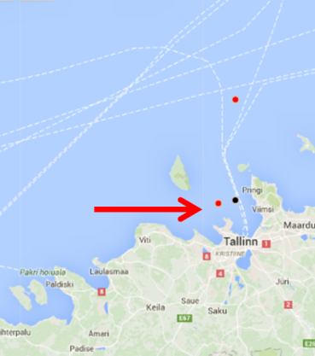
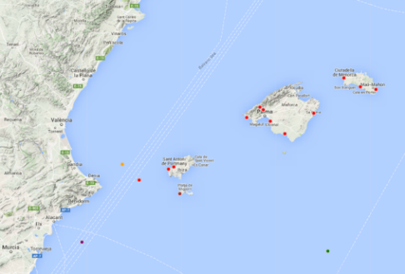 | 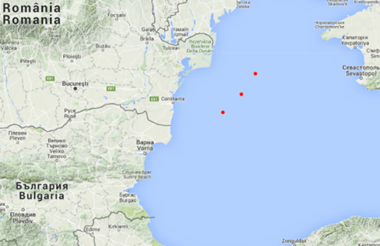
Activities are going on to enhance access to HF Radar data from 11 systems. Integration in the INSTAC will happen when the EuroGOOS task Team has finalize recommendation for data harmonization. Additional systems from Malta and Croatia available in a near future
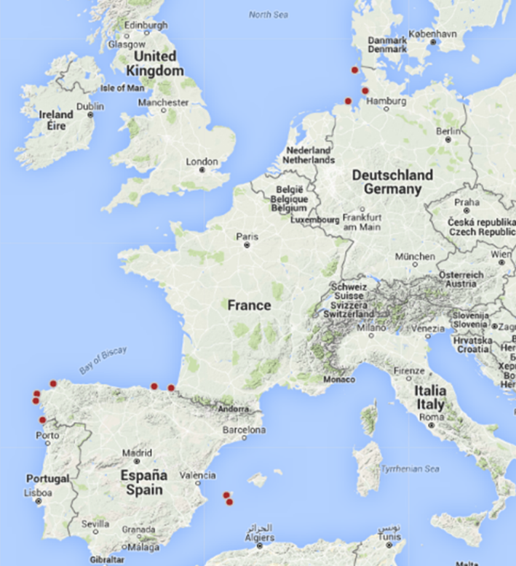

EuroGOOS has also be active in promoting the INSTAC linked to promotion of ROOSs, EMODnet and other data initiatives
- JERICO-NEXT KO, 28 September – 1 October, Mallorca
- Tide Gauge Task Team meeting, – task to identifying additional platforms to be included in the current data exchange system, 8 October, Madrid, Spain
- Key note at FixO3 General Assembly promoting data sharing. Ongoing discussions with FixO3 to enable access to data not yet in INSTAC. 12 – 14 October, Brussels, Belgium
- EMODnet Jamboree, 20 – 22 October, Oostende, Belgium
- MONGOOS Annual meeting, 3-6 November, Palma Mallorca, Spain
- CEFAS, 11 November, Lowestoft, UK. Lunch seminar on the European data landscape and discussion on access to UK data
- Italian EMODnet Day, 25 November, Rome, Italy
- Meeting with Mercator, 25 November, Toulouse, France
- Arctic ROOS Annual Meeting, 30 November – 1 December, Reykjavik, Iceland
- AtlantOS WP7 meeting, 3 -4 December, Paris, France
- EMODnet Steering Committee Meeting, 9 – 10 December, Brussels, Belgium
For early 2016 Eurogoos plans:
- Visit to HZG, German for Ferrybox data, 17 February, 2016
- EMODnet/EuroGOOS Data workshop in Germany, 18 February, 2016
- Planned meeting with EEA February, 2016
- Black Sea meeting and data workshop planned February, 2016
- Ongoing discussions with Turkey,, Morocco , UK for additional data workshops
EuroGOOS will also work to facilitate new platforms integration 2016/17
- Wave gliders
- Cable observatories
- Tagged seals in cooperation with Mammals TT
- Underwater noise
EuroGOOS also initiated discussion with ICES, JCOMMOPS and relevant GOOS GRAs. Meeting planned for early 2016.

TASK 4 CROSS CUTTING ACTIVITIEs

Product Quality (Task 4.1)
The main objective for this task is to ensure the cross cutting activity between the different components of the CMEMS service concerning the product quality. In the reporting period, IMR as the contact point with Mercator Ocean for the INSTAC regarding the product assessment and review process has drafted and via iteration with the INSTAC partners finalised the Scientific validation Plan as well as produced a quite similar Scientific Calibration Plan for the INSTAC V2 system. Within the review process for the V2 it became obvious, that the understanding of the item Calibration of the INSTAC system has been subject for misunderstandings between Mercator Ocean and the INSTAC consortium. First steps to improve the situation respectively to converge to a common understanding were undertaken and will be further improved by direct discussions between the INSTAC contact point and Mercator Ocean in the start of 2016.
The process for producing the Quality Information Documents for the INSTAC V2 products have been initiated.
The scientific experts defined in the preparation phase (J Tintore (SOCIB) and H Wehde (IMR) were unfortunately not able to attend the first Product Quality Working Group meeting in October because of short notice and inflexible dates of the meeting. However INSTAC managed to have a represention at the meeting by Charles Troupin (SOCIB), Jerome Gourrion (IFREMER) and Vidar Lien (IMR, also associated to the Arctic MFC) participating.

Multi Year data Timeseries and Ocean State Report (Task 4.2)
This task operates through the cross-cutting activities (MFCs, TACs, Mercator) and direct collaboration with Mercator. The main objectives are:
- Development and improvement of validation of multi-year products (collaboration with 4.1 Product Quality and 4.3 Service evolution)
- Contribution to the drafting of the OSR

This task is directly related to task 3.1.3. The development and improvement of validation of multi-year products has been discussed in particular in the PQWG-MYP in Toulouse in October 2015 (including MFCs, TACS and Mercator). The improvement of the global in situ data quality control have been presented as well as the approach supported by the scientific leaders for the multi-year products. They insist on the use of multi-platform and multi-scale observations to monitor the variability at the right scales (eg mesoscale). The increased amount of in situ data, their duration (long time series available) and diversification of observation platforms allowing the monitoring of the ocean state as well as the variability from the coast to the open ocean, from local to regional and global scales, and from (sub-)mesoscale to inter-annual scales).
The work plan 2016 have been established:
- Continue to identify key sections/stations where long time series of in situ data are available and where the ocean variability is dynamically relevant in terms of transports, water masses, and variability (among others: general circulation variability through control sections -Ibiza Channel, entrance of Barents Sea and the Baltic Sea, etc.- water masses variability related to circulation)
- Definition and variability of regional integrated quantities (eg heat and salt contents in different vertical layers, mixed layer depth, water mass distribution)

In November 2015, a teleconference was conducted by Karina von Schuckmann (Ocean State Report Task Team) to discuss about the actions to compile the OSR.
The agreed actions concern the structuration of the OSR, suggestions for the Ocean Monitoring Indicators, the spatial and temporal scales to be solved for the analysis, suggestions for (sub-)leaders and potential external reviewers. Draft with ideas (to be discussed and completed) of ocean indicators is expected at the end of December. Video conference is planned in January 2016.

Service Evolution (Task 4.3)
The InSitu Thematic Assembly Center (INSTAC) has performed a lot of development work concerning the Near Real Time (NRT) data products prior to the CMEMS service within the MyOcean suite of projects. Additional activities for the improvement of the NRT products is planned both in the H2020 projects such as AtlantOS for multiplatform procedures and in JERICO-Next for coastal observations. The implementation of these improvements is ensured via the involvement of the INSTAC partners in those projects.
Therefore we are mainly aiming at the development of the Multiyear/Reprocessed products as focal point for the service evolution.
The multi-year In-Situ products are actually built as an additional assessment on a frozen copy of the NRT product at a certain time. The additional assessment activities will:
- clean up the multi-year products from a lot of outliers that can be detected in NRT
- provide the information on the updates made back to INSTAC global and regional databases and whenever possible to the data providers using a feedback process so that the NRT products benefit from multi-year reprocessing.
The planned activity has been split in four domains:
- the physical
- the biogeochemical
- the development of waves products
- the improvement of upstream or downstream interfaces
For all the three first items we aim for:
- Improvement of both temporal and spatial resolution, including new platforms and networks
- Improvement of the individual algorithms for all regions
- Improvement of the delivery timeliness of NRT products
- Extension of reprocessed dataset time-series (back in time)
For the improvement of up- respectively downstream interfaces focal point will be laid on the:
- Improvement of the interfaces for dissemination
- Improvement of the interfaces with MFCs
- Improvement of interfaces with upstream providers
A detailed document describing the plans for the upcoming 3 and 6 years were provided and updated as revised document to Mercator Ocean. The development work itself is detailed in the progress reported for the Task 3 and its specific subtasks.

Communication (Task 4.4)
The main objective of this task is to provide more visibility to the in situ data and to highlight the multi-platform nature of the ocean observation nowadays.
To do so, we committed to provide high-resolutions figures and animations 2 times a year, as well as Downstream Use Cases that describe the CMEMS added-value in specific applications or tools developed by users.
A first set of graphical material was sent to Mercator-Océan Communication team in late August. It consisted of:
- high-resolution figures showing the temperature anomalies with respected to a climatology in the Mediterranean Sea, based on in situ data available from the FTP;
- an animation showing the trajectory of a drifting along the edge of a mesoscale eddy with the temperature measured by the drifters.
A second set of material is ready to be sent by the 3rd week of December 2015. It consists of:
- an animation showing the temperature and salinity signature of a cold blob present in the north Atlantic Ocean, based on a gridded fields generated from in situ data;
- a global map showing the platform locations and types for the 1st of December 2015. The goal is to illustrate the variety of platforms collecting data as well as the typical spatial coverage that can be achieved with the in situ data.
In addition to the graphical material, a Downstream Use Case describing the "Seaboard Sorrento" (support decision-making tool for the Sorrento vessel accident in Mallorca) was published on September 8, 2015: http://marine.copernicus.eu/web/87-downstream-use-cases.php?item=2536.
During the September plenary meeting, contacts have been established with the different regional leaders in order to prepare specific figures, animations and use cases for the year 2016.

Training (Task 4.5)
This task implies the development of training material dedicated to the current version of the products in the form of presentations and tutorials that show the users:
- the multi-platform observing systems,
- the relative scarcity of in situ data,
- the importance of quality control and quality flags assigned to the observations.
The INSTAC participated to the two Regional and User Training Workshops (RUTW) organised in 2015.
1st RUTW: Mediterranean Sea: during the workshop, Antonis Chalkiopoulos (HCMR) and Charles Troupin (SOCIB) gave a presentation focused on the importance of in situ data in oceanography and described the access to in situ data through the CMEMS web page. They were available for the users' questions and requests concerning the data use and access.
2st RUTW: IBI area: Fernando Manzano (Puertos del Estado) and Charles Troupin gave a 30-minute presentation introducing the relevance of in situ data in oceanography and described how to access them. During the afternoon session, they provided specific training to users to explain how to visualise and process the data using Ocean Data View and Python.
Following the requirements indicated in the Statement of Work, reports concerning the two training sessions were sent to Mercator-Océan Communication team.
The training material in Python is available since September 2015 on GitHub (web-based Git repository hosting service that allows distributed revision control and source code management): https://github.com/ctroupin/OceanData_NoteBooks. New examples of code will be progressively added, depending on the user requests.
The supports (PowerPoint) for the presentations given during the two workshops have been provided to Mercator-Océan Communication team, so that they will make them available on the Training section of the webpage: http://marine.copernicus.eu/web/99-next-sessions.php
For the next months, the training material will be adapted to the other regions (Northwest Shelf, Global and Baltic) where a training course will take place in 2016.
Additional examples of code will show how to read, visualise and interpret data from different platforms (profilers, drifters, gliders, moorings …).

Status of Deliverables
List the delivery (documents, new or updated products) done during the period and the status of the delivery for the next period
Documents:
Reference | Due date | Status | Version/Date | date of delivery
CMEMSF-INS-MP-1.1 | 01/09/2015 | delivered | V1.1 / 26-08-2015 | 01/09/2015
CMEMSF-INS-V2-PS-1.1 | 01/09/2015 | delivered | V1.1 / 26-08-2015 | 01/09/2015
CMEMS-INS-CMP-1.1 | 01/09/2015 | delivered | V1.1 / 01-09-2015 | 01/09/2015
CMEMS-INS-OLA-V1.1 | 01/09/2015 | delivered | V1.1 / 01-09-2015 | 01/09/2015
CMEMS-INS-SIOPM-1.1 | 01/09/2015 | delivered | V1.1 / 01-09-2015 | 01/09/2015
CMEMS-INSTAC-ComplianceMatrix-V1.1 | 01/09/2015 | delivered | V1.1 / 28-08-2015 | 01/09/2015
CMEMS-INS-SRD-SystemRequirementsDocument-1.1 | 31/08/2015 | delivered | V1.1 / 27-08-2015 | 01/09/2015
CMEMS-INS-ADD-ArchitectureDesignDocument-1.1 | 01/09/2015 | delivered | V1.1 / 28-08-2015 | 01/09/2015
CMEMS-INS-TD-TestsDescriptionDistributionUnit-1.1 | 01/09/2015 | delivered | V1.1 / 27-08-2015 | 01/09/2015
CMEMS-PQ-ScCP-INSTAC-1.0 | 15/09/2015 | delivered | V1.0 11/09/2015 | 11/09/2015
CMEMS-PQ-ScVP-INSTAC-1.0 | 15/09/2015 | delivered | V1.0 11/09/2015 | 11/09/2015
CMEMSV1.1_INS_PIT_V1.1 | 01/09/2015 | delivered | V1.1 / 31-08-2015 | 01/09/2015
CMEMS-INS-2016WorkPlan-V1.1 | 10/11/2015 | Delivered | 1.1 / 16/11/2015 | 16/11/2015
All the documents are under revision to take into account the feedback from the Design Review V2 that was sent to us on the 5th November 2015 and due for the 26th January 2016
Moreover the revised Workplan for 2016 will be delivered together with the Annual Activity report ( this document ) for the 8th January 2016

Product list for CMEMS-V1
Product Name | Update description | CMEMS Version
Global- NRT | Time coverage (1990- ongoing) | CMEMS V1
Arctic NRT | Time coverage (1990- ongoing) | CMEMS V1
Baltic NRT | Time coverage (1990- ongoing) | CMEMS V1
NWS NRT | Time coverage (1990- ongoing) | CMEMS V1
IBI NRT | Time coverage (1990- ongoing) | CMEMS V1
Med Sea NRT | Time coverage (1990- ongoing) | CMEMS V1
Black Sea NRT | Time coverage (1990- ongoing) | CMEMS V1
Global T&S REP +Gridded | Time coverage (1950-2013) | CMEMS V1
Global REP Gridded T&S | Time coverage (1950-2013) | CMEMS V1
Arctic T&S REP | Time coverage (1950-2013) | CMEMS V1
Baltic T&S REP | Time coverage (1950-2013) | CMEMS V1
NWS T&S REP | Time coverage (1950-2013) | CMEMS V1
IBI T&S REP | Time coverage (1950-2013) | CMEMS V1
Med Sea T&S REP | Time coverage (1950-2013) | CMEMS V1
Black Sea T&S REP | Time coverage (1950-2013) | CMEMS V1

Product Updates planned for CMEMS-V2
In V2 the INS TAC is providing the NRT products one product per region and REProcessed T&S product also one per region. These products have been prepared in 2015 , there are updates from V1 over longer time period. In addition for the global region a new Current REProcessed product will be added to the catalogue.

Product Name | Creation/ Update | Update description | CMEMS Version
Global- NRT | Update | Increase Time coverage (1990- ongoing) | CMEMS V2
Arctic NRT | Update | Increase Time coverage (1990- ongoing) | CMEMS V2
Baltic NRT | Update | Increase Time coverage (1990- ongoing) | CMEMS V2
NWS NRT | Update | Increase Time coverage (1990- ongoing) | CMEMS V2
IBI NRT | Update | Increase Time coverage (1990- ongoing) | CMEMS V2
Med Sea NRT | Update | Increase Time coverage (1990- ongoing) | CMEMS V2
Black Sea NRT | Update | Increase Time coverage (1990- ongoing) | CMEMS V2
Global T&S REP +Gridded | Update | Increase Time coverage (1950-2014) | CMEMS V2
Global REP Gridded T&S | Update | Increase Time coverage (1990-2014) | CMEMS V2
Global REP CURRENT | New | Current REProcessed product from drifters (1990-2014) | CMEMS V2
Arctic T&S REP | Update | Increase Time coverage (1990-2014) | CMEMS V2
Baltic T&S REP | Update | Increase Time coverage (1990-2014) | CMEMS V2
NWS T&S REP | Update | Increase Time coverage (1990-2014) | CMEMS V2
IBI T&S REP | Update | Increase Time coverage (1990-2014) | CMEMS V2
Med Sea T&S REP | Update | Increase Time coverage (1990-2014) | CMEMS V2
Black Sea T&S REP | Update | Increase Time coverage (1990-2014) | CMEMS V2

